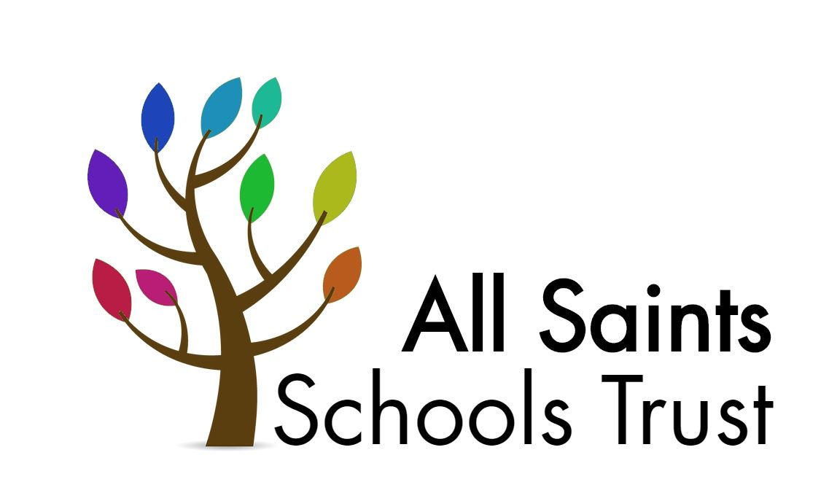

Child Protection and Safeguarding Policy

Including PREVENT/Channel (radicalisation/extremism)

Approved: September 2021
To be reviewed: September 2022

All Saints Schools Trust

Child Protection and Safeguarding Policy

Prepared by: | Melanie Barrow CEO
Approved by: | ASST Trust Board
Signature of Chair of Trustees:

Status & review cycle | Statutory Annual
Date approved: | 16.9.21
Review date: | September 2021

Table of Contents

- Ethos statement

- Introduction

- Statutory framework

- Key roles and responsibilities

- Training

- Recognising concerns – signs and indicators of abuse

- Specific safeguarding issues

- Children potentially at greater risk of harm

- Curriculum

- Online safety

- Peer on peer abuse

- Procedures

- Information sharing, record keeping and confidentiality

- Managing allegations made against teachers, including supply teachers, other staff, volunteers and contractors.

- Use of school premises for non-school activities

- Whistleblowing

- Appendix A – School DSL and contact leads

- Appendix B- further information on specific safeguarding issues

- Appendix C – recording form for safeguarding concerns

- Appendix D – body map

- Appendix E Prevent/ CHANEL (Radicalisation and Extremism)

School DSL and contact details

In an emergency the CEO can be contacted:
Melanie Barrow
07547 123335
m.barrow@asst.org.uk

Trust Safeguarding Trustee: Russell Ayling

All Saints, Laxfield Primary
Role: | Name and contact details:
Designated Safeguarding Lead (DSL) | Melanie Barrow  07547 123335  m.barrow@asst.org.uk
Alternate DSL | Katharine Minns  01986 798344  k.minns@laxfieldprimary.org.uk
Named safeguarding governor | Ben Hemmings  01379 384415  b.hemmings@stradbrokeprimary.org.uk
Chair of Governors | Tim Mawson  01986 798344  t.mawson@asst.org.uk
School e-Safety Lead | Daniel Millican  01986 798344
Designated teacher for Children in Care and children previously in care (CiC) | Melanie Barrow  07547 123335  m.barrow@asst.org.uk

Charsfield Primary
Role: | Name and contact details:
Designated Safeguarding Lead (DSL) | Mark Taylor  m.taylor@asst.org.uk  01473 737347
Alternate DSL | Amie Reeve  01473 737347
Named safeguarding governor | Jo Read  01473 737347
Chair of Governors | Steve Lovett  01473 737347
School e-Safety Lead | Mark Taylor  m.taylor@asst.org.uk  01473 737347
Designated teacher for Children in Care and children previously in care (CiC) | Mark Taylor  m.taylor@asst.org.uk  01473 737347

Dennington Primary
Role: | Name and contact details:
Designated Safeguarding Lead (DSL) | Charys Rushbrook  charys.rushbrook@dennington.suffolk.sch.uk  01728 638206
Alternate DSL | Jenny Turner  jenny.turner@dennington.suffolk.sch.uk  01728 638206
Named safeguarding governor | Anne Lawrence  01728 638206
Chair of Governors | Lucy Long  Kate Fell  01728 638206
School e-Safety Lead | Paul Parslow-Williams  paul.williams@asst.org.uk  01728 638206
Designated teacher for Children in Care and children previously in care (CiC) | Charys Rushbrook  charys.rushbrook@dennington.suffolk.sch.uk  01728 638206

Fressingfield Primary
Role: | Name and contact details:
Designated Safeguarding Lead (DSL) | Mark Taylor  m.taylor@asst.org.uk  01379 586393
Alternate DSL | Jeremy Leicester  J.Leicester@fressingfieldprimary.org.uk  01379 586393
Named safeguarding governor | Prue Rush  01379 586393
Chair of Governors | Clare Foster-Clarke  01379 586393
School e-Safety Lead | Mark Taylor  m.taylor@asst.org.uk  01379 586393
Designated teacher for Children in Care and children previously in care (CiC) | Mark Taylor  m.taylor@asst.org.uk  01379 586393

Great Whelnetham Primary
Role: | Name and contact details:
Designated Safeguarding Lead (DSL) | Claire Flatman  c.flatman@asst.org.uk  01284 386203
Alternate DSL | Imogen Wallis  iwallis@greatwhelnetham.co.uk  01284 386203
Named safeguarding governor | Jeremy Cladd  01284 386203
Chair of Governors | Caroline Robinson  01284 386204
School e-Safety Lead | Claire Flatman  c.flatman@asst.org.uk  01284 386203
Designated teacher for Children in Care and children previously in care (CiC) | Claire Flatman  c.flatman@asst.org.uk  01284 386203

Hardwick Primary
Role: | Name and contact details:
Designated Safeguarding Lead (DSL) | Daryl Jones  djones@hardwick365.net  01284 755424
Alternate DSL | Nick Wells nwells@hardwick365.net  Zara Cowling zcowling@hardwick365.net  Nick Shore nshore@hardwick365.net  Clare Peck cpeck@hardwick365.net  01284 755424
Named safeguarding governor | Chloe I’Anson,  Paul Nicholls  01284 755424
Chair of Governors | Robert Heavisides  01284 755424
School e-Safety Lead | Nick Wells  nwells@hadwick365.net
Designated teacher for Children in Care and children previously in care (CiC) | Daryl Jones  djones@hardwick365.net  01284 755424

Occold Primary
Role: | Name and contact details:
Designated Safeguarding Lead (DSL) | Gemma Watts  gemma@occoldprimaryschool.org  01379 678330
Alternate DSL | Paul Parslow-Williams  Paul.williams@asst.org.uk  01379 678330
Named safeguarding governor | Carol Peters  01379 678330
Chair of Governors | Carol Peters  01379 678330
School e-Safety Lead | Gemma Watts  gemma@occoldprimaryschool.org  01379 678330
Designated teacher for Children in Care and children previously in care (CiC) | Gemma Watts  gemma@occoldprimaryschool.org  01379 678330

Stradbroke Primary
Role: | Name and contact details:
Designated Safeguarding Lead (DSL) | Melanie Barrow  m.barrow@asst.org.uk  07547 123335
Alternate DSL | Hannah Hunt/ Hannah Cragoe  h.hunt@stradbrokeprimary.org.uk  h.cragoe@stradbrokeprimary.org.uk  01379 384415
Named safeguarding governor | Ben Hemmings  b.hemmings@stradbrokeprimary.org.uk  01379 384415
Chair of Governors | Tim Mawson  01986 798344  t.mawson@asst.org.uk
School e-Safety Lead | Hannah Hunt  h.hunt@stradbrokeprimary.org.uk  01379 384415
Designated teacher for Children in Care and children previously in care (CiC) | Melanie Barrow  m.barrow@asst.org.uk  07547 123335

St Peter and St Pauls, Eye Primary
Role: | Name and contact details:
Designated Safeguarding Lead (DSL) | Melanie Barrow  m.barrow@asst.org.uk  07547 123335
Alternate DSL | Paul Parslow-Williams  paul.williams@asst.org.uk  01379 870497  Caroline Jarvis  c.jarvis@eyeprimarysuffolk.org  01379 870497
Named safeguarding governor | Sarah Mortimer  01379 870497
Chair of Governors | Odile Wladon  o.wladon@asst.org.uk  01379 870497
School e-Safety Lead | Sophie Brown  s.brown@eyeprimarysuffolk.org  01379 870497
Designated teacher for Children in Care and children previously in care (CiC) | Melanie Barrow  m.barrow@asst.org.uk  07547 123335

Wortham Primary
Role: | Name and contact details:
Designated Safeguarding Lead (DSL) | Claire Flatman  c.flatman@asst.org.uk  01379 898484
Alternate DSL | Bobby Varela  01379 898484
Named safeguarding governor | Barry Coles  01379 898484
Chair of Governors | Jeanne Jenkins  01379 898484
School e-Safety Lead | Bobby Varela  01379 898484
Designated teacher for Children in Care and children previously in care (CiC) | Claire Flatman  c.flatman@asst.org.uk  01379 898484

School Child Protection and Safeguarding Policy Framework
Safeguarding and promoting the welfare of children is everyone’s responsibility. Everyone who comes into contact with children and their families has a role to play. In order to fulfil this responsibility effectively, all practitioners should make sure their approach is child-centred. This means that they should consider, at all times, what is in the best interests of the child.
(Keeping Children Safe in Education)

Ethos statement
We recognise the moral and statutory responsibility placed on all staff to safeguard and promote the welfare of all children. We aim to provide a safe and welcoming environment, underpinned by a culture of openness where both children and adults feel secure, are able to raise concerns and believe they are being listened to, and that appropriate action will be taken to keep them safe.

Introduction
The Trust Board and Governing Bodies recognises the need to ensure that it complies with its duties under legislation and this policy has regard to statutory guidance, Keeping Children Safe in Education (KCSiE), Working Together to Safeguard Children and locally agreed inter-agency procedures put in place by Suffolk Safeguarding Partnership Board.

This policy will be reviewed annually, as a minimum, and will be made available publicly via the school website or on request.

Safeguarding and promoting the welfare of children is defined as: protecting children from maltreatment; preventing impairment of children’s mental and physical health or development; ensuring that children grow up in circumstances consistent with the provision of safe and effective care; and taking action to enable all children to have the best outcomes.

This policy is for all staff, parents, governors, volunteers and the wider school community. It forms part of the child protection and safeguarding arrangements for our school and is one of a suite of policies and procedures which encompass the safeguarding responsibilities of the school In particular, this policy should be read in conjunction with the school’s Code of Conduct/Staff Behaviour Policy (including Acceptable Use of ICT), Safer Recruitment Policy, E-Safety Policy, Anti-Bullying Policy, and Department for Education (DfE) guidance Sexual Violence and Sexual Harassment Between Children in Schools and Colleges.

The aims of this policy are to:

- Provide staff with a framework to promote and safeguard the wellbeing of children and young people, and ensure that they understand and meet their statutory responsibilities;
- Ensure consistent good practice across the school.

The Trust Board and Governing Bodies expect that all staff will know and understand this child protection and safeguarding policy and their responsibility to implement it. Staff working directly with children must, as a minimum, have read and understand Part One of KCSiE. Governors/the proprietor will ensure that they and senior leaders have read and understand Parts One and Two of KCSiE. The Trust Board and Governing Bodies will ensure that those staff who do not work directly with children will read either Part One or Annex A of KCSiE.

The Trust Board and Governing Bodies will ensure that arrangements are in place for all staff members to receive appropriate safeguarding and child protection training which is regularly updated.

Compliance with the policy will be monitored by the Headteacher, designated safeguarding lead (DSL) and named safeguarding Governors.

Statutory framework
Section 175 of the Education Act 2002 in the case of maintained schools and pupil referral units, Regulations 2014 for independent schools (including academies), place a statutory duty on governing bodies to have policies and procedures in place that safeguard and promote the welfare of children and young people who are pupils of the school which must have regard to any guidance given by the Secretary of State.
In accordance with statutory guidance, Working Together to Safeguard Children 2018, local safeguarding arrangements must be established for every local authority area by the three safeguarding partners (Local Authority, Police and Clinical Commissioning Groups). All three partners have equal and joint responsibility for a range of roles and statutory functions including developing local safeguarding policy and procedures and scrutinising local arrangements. In Suffolk, all schools have been named by the Suffolk Safeguarding Partnership (SSP) as relevant agencies, this means staff in schools must work in accordance with the multi-agency procedures developed by the Suffolk Safeguarding Partnership (SSP) which can be found on their website at: https://suffolksp.org.uk/.

Key roles and responsibilities
Trust Board and Governing Bodies
The Trust Board and Governing Bodies have a strategic leadership responsibility for the school’s safeguarding arrangements and must ensure that they comply with their duties under legislation. The Trust has a legal responsibility to make sure that there are appropriate policies and procedures in place, which have regard to statutory guidance, in order for appropriate action to be taken in a timely manner to safeguard and promote children and young people’s welfare. The Trust Board and Governing Bodies will also ensure that the policy is made available to parents and carers by publishing this on the school website or in writing if requested.
The Trust Board and Governing Bodies will ensure they facilitate a whole school approach to safeguarding. This means ensuring safeguarding and child protection are at the forefront and underpin all relevant aspects of process and policy development, and that all systems, processes and policies operate with the best interests of the child at their heart.
The Trust Board and Governing Bodies will ensure that where there is a safeguarding concern school leaders will make sure the child’s wishes and feelings are taken into account when determining what action to take and what services to provide. Systems will be in place that are well promoted, easily understood and easily accessible for children to confidently report abuse, knowing their concerns will be treated seriously, and knowing they can safely express their views and give feedback.
The Trust Board and Governing Bodies will ensure that the school contributes to multi-agency working in line with statutory guidance Working Together to Safeguard Children and that the school’s safeguarding arrangements take into account the procedures and practice of the locally agreed multi-agency safeguarding arrangements in place.
The governing body will ensure that policies for special educational needs and disability, and supporting pupils in school with medical conditions, are in place and are reflective of safeguarding as appropriate.
It is the responsibility of the governing body to ensure that staff and volunteers are properly vetted to make sure they are safe to work with the pupils who attend our school and that the school has procedures for appropriately managing allegations of abuse made against members of staff (including the headteacher, supply teachers, contractors, and volunteer helpers).
The governing body will ensure that there is a named governor for safeguarding, a Designated Safeguarding Lead (DSL) who has lead responsibility for safeguarding and child protection, and a designated teacher to promote the educational achievement of children who are looked after, or previously looked after, and will ensure that these people have the appropriate training.
The governing body will inform Suffolk County Council annually about the discharge of their safeguarding duties by completing the safeguarding self-assessment audit.
Designated Safeguarding Lead (DSL)
The DSL should take lead responsibility for safeguarding and child protection (including online safety). This should be explicit in the role-holder’s job description. (The broad areas of responsibility and activities related to the role of the DSL are set out in Annex C of KCSiE).
The DSL will have the appropriate status, authority, and time to carry out the duties of the post.
The DSL and any alternate DSLs should liaise with the local authority and work with other agencies in line with Working Together to Safeguard Children.
During term time, the DSL and/or an alternate should always be available during school hours for staff to discuss any safeguarding concerns. The DSL will make arrangements for adequate and appropriate cover arrangements for any out of hours/out of term time activities.
The DSL will undergo training to provide them with the knowledge and skills to carry out the role. This training will be updated every two years.
Headteacher/ Head of School
The headteacher will ensure that the policies and procedures adopted by the governing body are fully implemented and that sufficient resources and time are allocated to enable staff members to discharge their safeguarding responsibilities.
All staff
All staff have a responsibility to provide a safe environment in which children can learn.
All staff working directly with children must read and ensure they understand at least Part One of KCSiE. Those staff that do not work directly with children must read and ensure they understand either at least Part One or Annex A of KCSiE.
All staff must ensure they are familiar with the systems within school which support safeguarding, including the child protection and safeguarding policy, the code of conduct/staff behaviour policy, the behaviour policy, the safeguarding response to children who go missing from education, and the role of the DSL (including the identity of the DSL and any deputies).
All staff should be aware of indicators of abuse and neglect so that they are able to identify cases of children who may be in need of help or protection.
All staff should be able to reassure victims that they are being taken seriously and that they will be supported and kept safe. A victim should never be given the impression that they are creating a problem by reporting abuse, sexual violence or sexual harassment. Nor should a victim ever be made to feel ashamed for making a report.
All staff should know what to do if a child tells them he/she is being abused, neglected or exploited, and/or is otherwise at risk of involvement in criminal activity, such as knife crime, or involved in county lines drug dealing.
All staff should be aware of the process for making referrals to children’s social care and for statutory assessments under the Children Act 1989 that may follow a referral, especially section 17 (children in need) and section 47 (a child suffering, or likely to suffer, significant harm) along with the role they might be expected to play in such assessments.
All staff should be aware of the early help process and understand their role within it. This includes providing support as soon as a problem emerges, liaising with the DSL, and sharing information with other professionals in order to support early identification and assessment, focussing on providing interventions to avoid escalation of worries and needs (see Section 12: Information Sharing). In some cases, staff may be asked to act as the lead professional in undertaking an early help assessment.
Any child may benefit from early help, but all school and college staff should be particularly alert to the potential need for early help for a child who:
- is disabled or has certain health conditions and has specific additional needs
- has special educational needs (SEN) (whether or not they have a statutory Education, Health and Care Plan)
- has a mental health need
- is a young carer
- is showing signs of being drawn in to anti-social or criminal behaviour, including gang involvement and association with organised crime groups or county lines
- is frequently missing/goes missing from care or from home
- is at risk of modern slavery, trafficking or sexual or criminal exploitation
- is at risk of being radicalised or exploited
- has a family member in prison, or is affected by parental offending
- is in a family circumstance presenting challenges for the child, such as drug and alcohol misuse, adult mental health issues or domestic abuse
- is misusing drugs or alcohol themselves
- has returned home to their family from care
- is at risk of ‘honour’-based abuse such as Female Genital Mutilation (FGM) or forced marriage
- is a privately fostered child
- is persistently absent from education, including persistent absences for part of the school day

Knowing what to look out for is vital to the early identification of abuse and neglect and specific safeguarding issues such as child criminal exploitation and child sexual exploitation. If staff are unsure, they should always speak to the DSL (or deputy). If in exceptional circumstances the DSL (or deputy) is not available, this should not delay appropriate action being taken. Staff should consider speaking to a member of the senior leadership team and/or take advice from children’s social care. In these circumstances, any action taken should be shared with the DSL as soon as is practically possible. For DSL see

Training
The governing body will ensure that all staff receive appropriate safeguarding and child protection training which is regularly updated and in line with advice from SSP. In addition, all staff members will receive regular safeguarding and child protection (including online safety) updates (for example, via email, e-bulletins, staff meetings) as required, but at least annually, to provide them with relevant skills and up to date knowledge of emerging and evolving safeguarding issues to safeguard children effectively.

All new staff members will undergo safeguarding and child protection training at induction. This will include training on the school’s safeguarding and child protection policy, online safety, the code of conduct/staff behaviour policy, the behaviour policy, the safeguarding response to children who go missing from education, and the role of the designated safeguarding lead. Copies of the school’s policies, procedures and Part One of KCSiE (or Annex B for those staff who do not work directly with children) will be provided to new staff at induction.

The governing body will ensure that safeguarding training for staff, including online safety training, is integrated, aligned and considered as part of the whole school safeguarding approach and wider staff training and curriculum planning.

The Headteacher/ Head of School will ensure that an accurate record of safeguarding training undertaken by all staff is maintained and updated regularly.

In considering safeguarding training arrangements the governing body/proprietor will also have regard to the Teachers’ Standards which set out the expectation that all teachers manage behaviour effectively to ensure a good and safe educational environment, and require teachers to have a clear understanding of the needs of all pupils.

Recognising concerns - signs and indicators of abuse.
All staff should be aware of indicators of abuse and neglect, and specific safeguarding issues such as child criminal exploitation and child sexual exploitation, so that they are able to identify cases of children who may be in need of help or protection.

All staff should be aware that abuse, neglect and safeguarding issues are rarely standalone events that can be covered by one definition or label. In most cases, multiple issues will overlap with one another, therefore staff should always be vigilant and always raise any concerns with their DSL.

All staff should be aware that technology is a significant component in many safeguarding and wellbeing issues. Children are at risk of abuse online as well as face to face. In many cases abuse will take place concurrently via online channels and in daily life. Children can also abuse their peers online, this can take the form of abusive, harassing, and misogynistic messages, the non-consensual sharing of indecent images, especially around chat groups, and the sharing of abusive images and pornography, to those who do not want to receive such content.

All staff should be aware that safeguarding incidents and/or behaviours can be associated with factors outside the school and/or can occur between children outside of this environment. All staff, but especially the DSL (and deputies), should consider whether children are at risk of abuse or exploitation in situations outside their families. Extra-familial harms take a variety of different forms and children can be vulnerable to multiple harms including (but not limited to) sexual exploitation, criminal exploitation, sexual abuse, serious youth violence and county lines.

Indicators of abuse and neglect

Abuse is defined as a form of maltreatment of a child. Somebody may abuse or neglect a child by inflicting harm or by failing to act to prevent harm. Children may be abused in a family or in an institutional or community setting by those known to them or, more rarely, by others. Abuse can take place wholly online, or technology may be used to facilitate offline abuse. They may be abused by an adult or adults or another child or children.

The following indicators listed under the categories of abuse are not an exhaustive list:

Physical abuse: a form of abuse which may involve hitting, shaking, throwing, poisoning, burning or scalding, drowning, suffocating or otherwise causing physical harm to a child. Physical harm may also be caused when a parent or carer fabricates the symptoms of, or deliberately induces, illness in a child.
Emotional abuse: the persistent emotional maltreatment of a child such as to cause severe and adverse effects on the child’s emotional development. It may involve conveying to a child that they are worthless or unloved, inadequate, or valued only insofar as they meet the needs of another person. It may include not giving the child opportunities to express their views, deliberately silencing them or ‘making fun’ of what they say or how they communicate. It may feature age or developmentally inappropriate expectations being imposed on children. These may include interactions that are beyond a child’s developmental capability as well as overprotection and limitation of exploration and learning, or preventing the child participating in normal social interaction. It may involve seeing or hearing the ill-treatment of another. It may involve serious bullying (including cyberbullying), causing children frequently to feel frightened or in danger, or the exploitation or corruption of children. Some level of emotional abuse is involved in all types of maltreatment of a child, although it may occur alone.
Sexual abuse: involves forcing or enticing a child or young person to take part in sexual activities, not necessarily involving violence, whether or not the child is aware of what is happening. The activities may involve physical contact, including assault by penetration (for example rape or oral sex) or non-penetrative acts such as masturbation, kissing, rubbing and touching outside of clothing. They may also include non-contact activities, such as involving children in looking at, or in the production of, sexual images, watching sexual activities, encouraging children to behave in sexually inappropriate ways, or grooming a child in preparation for abuse (including via the internet). Sexual abuse is not solely perpetrated by adult males. Women can also commit acts of sexual abuse, as can other children. The sexual abuse of children by other children is a specific safeguarding issue (also known as peer on peer abuse) in education and all staff should be aware of it and of the school’s policy and procedures for dealing with it. (See section 7: Specific safeguarding issues and Appendix A) [schools should cross-reference their school policy/procedures for dealing with peer-on-peer abuse within the school’s Child Protection and Safeguarding Policy)
Neglect: the persistent failure to meet a child’s basic physical and/or psychological needs, likely to result in the serious impairment of the child’s health or development. Neglect may occur during pregnancy as a result of maternal substance abuse. Once a child is born, neglect may involve a parent or carer failing to: provide adequate food, clothing and shelter (including exclusion from home or abandonment); protect a child from physical and emotional harm or danger; ensure adequate supervision (including the use of inadequate care-givers); or ensure access to appropriate medical care or treatment. It may also include neglect of, or unresponsiveness to, a child’s basic emotional needs.
(Source Keeping Children Safe in Education)

Specific safeguarding issues
All staff should have an awareness of safeguarding issues that can put children at risk of harm. Behaviours linked to issues such as of drug taking, alcohol abuse, deliberately missing education and consensual and non-consensual sharing of nudes and semi-nudes images and/or videos can be signs that children are at risk. Other safeguarding issues all staff should be aware of include:

Child sexual exploitation (CSE) and Child Criminal Exploitation (CCE)
Both CSE and CCE are forms of abuse and both occur where an individual or group takes advantage of an imbalance of power to coerce, manipulate or deceive a child into taking part in sexual or criminal activity, in exchange for something the victim needs or wants, and/or for the financial advantage or increased status of the perpetrator or facilitator and/or through violence or the threat of violence. CSE and CCE can affect children, both male and female and can include children who have been moved (commonly referred to as trafficking) for the purpose of exploitation.

Child Criminal Exploitation (CCE)
Some specific forms of CCE can include children being forced or manipulated into transporting drugs or money through county lines, working in cannabis factories, shoplifting or pickpocketing. They can also be forced or manipulated into committing vehicle crime or threatening/committing serious violence to others.
Children can become trapped by this type of exploitation as perpetrators can threaten victims (and their families) with violence, or entrap and coerce them into debt. They may be coerced into carrying weapons such as knives or begin to carry a knife for a sense of protection from harm from others. As children involved in criminal exploitation often commit crimes themselves, their vulnerability as victims is not always recognised by adults and professionals (particularly older children), and they are not treated as victims despite the harm they have experienced. They may still have been criminally exploited even if the activity appears to be something they have agreed or consented to.

It is important to note that the experience of girls who are criminally exploited can be very different to that of boys. The indicators may not be the same, however staff should be aware that girls are at risk of criminal exploitation too. It is also important to note that both boys and girls being criminally exploited may be at higher risk of sexual exploitation.

Further information about CCE including definitions and indicators in included in Appendix B

Child Sexual Exploitation (CSE)
CSE is a form of child sexual abuse. Sexual abuse may involve physical contact, including assault by penetration (for example, rape or oral sex) or nonpenetrative acts such as masturbation, kissing, rubbing, and touching outside clothing. It may include non-contact activities, such as involving children in the production of sexual images, forcing children to look at sexual images or watch sexual activities, encouraging children to behave in sexually inappropriate ways or grooming a child in preparation for abuse including via the internet.

CSE can occur over time or be a one-off occurrence, and may happen without the child’s immediate knowledge e.g. through others sharing videos or images of them on social media.

CSE can affect any child, who has been coerced into engaging in sexual activities. This includes 16 and 17 year olds who can legally consent to have sex. Some children may not realise they are being exploited e.g. they believe they are in a genuine romantic relationship.

Further information about CSE including definitions and indicators is included in Appendix B

Female Genital Mutilation (FGM)
Whilst all staff should speak to the DSL (or deputy) with regard to any concerns about FGM, there is a specific legal duty on teachers. If a teacher, in the course of their work in the profession, discovers that an act of FGM appears to have been carried out on a girl under the age of 18, the teacher must report this to the police. See Appendix B for further details.

Mental Health
All staff should be aware that mental health problems can, in some cases, be an indicator that a child has suffered or is at risk of suffering abuse, neglect or exploitation.

Only appropriately trained professionals should attempt to make a diagnosis of a mental health problem. Education staff, however, are well placed to observe children day-to-day and identify those whose behaviour suggests that they may be experiencing a mental health problem or be at risk of developing one.

Where children have suffered abuse and neglect, or other potentially traumatic adverse childhood experiences, this can have a lasting impact throughout childhood, adolescence and into adulthood. It is key that staff are aware of how these children’s experiences can impact on their mental health, behaviour and education.

Staff can access a range of advice to help them identify children in need of extra mental health support, this includes working with external agencies. More information can be found in the mental health and behaviour in schools guidance.

If staff have a mental health concern about a child that is also a safeguarding concern, immediate action should be taken, following the school’s policy, and speaking to the DSL or a deputy.

Peer on peer abuse
All staff should be aware that children can abuse other children (often referred to as peer on peer abuse). And that it can happen both inside and outside of school and online. It is important that all staff recognise the indicators and signs of peer on peer abuse and know how to identify it and respond to reports.

All staff should understand, that even if there no reports in school it does not mean it’s not happening, it may be the case that it is just not being reported. As such, it is important if staff have any concerns regarding peer on peer abuse they should speak to the DSL (or deputy).

It is essential that all staff understand the importance of challenging inappropriate behaviours between peers, many of which are listed below, that are actually abusive in nature. Downplaying certain behaviours, for example dismissing sexual harassment as “just banter”, “just having a laugh”, “part of growing up” or “boys being boys” can lead to a culture of unacceptable behaviours, an unsafe environment for children and in worst case scenarios a culture that normalises abuse leading to children accepting it as normal and not coming forward to report it.

Peer on peer abuse is most likely to include, but may not be limited to:

- bullying (including cyberbullying, prejudice-based and discriminatory bullying)
- Abuse in intimate personal relationships between peers
- physical abuse such as hitting, kicking, shaking, biting, hair pulling, or otherwise causing physical harm (this may include an online element which facilitates, threatens and/or encourages physical abuse)
- sexual violence, such as rape, assault by penetration and sexual assault (this may include an online element which facilitates, threatens and/or encourages sexual violence)
- sexual harassment, such as sexual comments, remarks, jokes and online sexual harassment, which may be stand-alone or part of a broader pattern of abuse.
- Causing someone to engage in sexual activity without consent, such as forcing someone to strip, touch themselves sexually, or to engage in sexual activity with a third party.
- Consensual and non-consensual sharing of nudes and semi nudes images and or videos (also known as sexting or youth produced sexual imagery)
- upskirting, which typically involves taking a picture under a person’s clothing without their permission, with the intention of viewing their genitals or buttocks to obtain sexual gratification, or cause the victim humiliation, distress or alarm; and
- initiation/hazing type violence and rituals (this could include activities involving harassment, abuse or humiliation used as a way of initiating a person into a group and may also include an online element)

All staff should be clear about the school’s policy and procedures with regards to peer on peer abuse and the important role they have to play in preventing it and responding where they believe a child may be at risk from it.

Serious violence
All staff should be aware of the indicators which may signal that children are at risk from, or involved with, serious violent crime. These may include increased absence from school, a change in friendships or relationships with older individuals or groups, a significant decline in performance, signs of self-harm or a significant change in wellbeing, or signs of assault or unexplained injuries. Unexplained gifts or new possessions could also indicate that children have been approached by, or are involved with, individuals associated with criminal networks or gangs and may be at risk of criminal exploitation.

All staff should be aware of the range of risk factors which increase the likelihood of involvement in serious violence, such as being male, having been frequently absent or permanently excluded from school, having experienced child maltreatment and having been involved in offending, such as theft or robbery.

Advice for schools is provided in the Home Office’s Preventing youth violence and gang involvement and its Criminal exploitation of children and vulnerable adults: county lines guidance
.

Further information about specific forms of abuse and safeguarding issues can be found in Appendix A. All staff should familiarise themselves with this.

Children potentially at greater risk of harm
The governing body/proprietor recognise that whilst all children should be protected there are some groups of children who are potentially at greater risk of harm and, in some cases, these children may find it difficult to communicate what is happening to them.

[Alternative Provision]
The management committee/proprietor recognises that the cohort of pupils in alternative provision often have complex needs and are/is aware of the additional risk of harm our pupils may be vulnerable to.

The management committee/proprietor will have regard to the following statutory guidance:
Alternative provision – DfE Statutory Guidance, and
Education for children with health needs who cannot attend school – DfE Statutory Guidance

Children who need a social worker (Child in Need and Child Protection Plans)
Children may need a social worker due to complex safeguarding or welfare needs. Children may need this help due to abuse, neglect and complex family circumstances. A child’s experiences of adversity and trauma can leave them vulnerable to further harm, as well as educationally disadvantaged in facing barriers to attendance, education, behaviour and mental health.

The governing body/proprietor expects that the Local Authority will share the fact a child has a social worker, and the DSL will hold and use this information so that decisions can be made in the best interests of the child’s safety, welfare and educational outcomes. This should be considered as a matter of routine. There are clear powers to share this information under existing duties on both LAs and school to safeguard and promote the welfare of children.

Where children need a social worker, this should inform decisions about safeguarding (for example, responding to unauthorised absence or missing education where there are known safeguarding risks) and about promoting welfare (for example, considering the provision of pastoral and/or academic support, alongside action by statutory services.

Children missing from education
Children missing education, particularly persistently, can indicate a warning sign to a range of safeguarding issues including neglect, sexual abuse and child sexual and criminal exploitation.

It is important that the school’s response to children missing from education supports identifying such abuse and also helps prevent the risk of them going missing in the future. This includes when problems are first emerging but also where children are already known to LA children’s social care and need a social worker (such as on a child in need or child protection plan, or as a looked after child), where going missing from education may increase known safeguarding risks within the family or in the community. As such, all staff should be aware of the school’s safeguarding response to children missing from education.

Further information and support includes:
- schools’ duties regarding children missing education, including information schools must provide to the LA when removing a child from the school roll at standard and non-standard transition points can be found in the DfE’s statutory guidance: Children Missing Education.
- General information and advice for schools can be found in the Government’s Missing Children and Adults Strategy.

Elective Home Education
Many home education children have an overwhelmingly positive learning experience. We would expect the parents’ decision to home educate to be made with their child’s best education at the heart of the decision. However, this is not the case for all, and home education can mean some children are less visible to the services that are there to keep them safe and supported in line with their needs.

Where a parent/carer has expressed their intention to remove a child from school with a view to educating at home, the school will work together with the LA and other key professionals to coordinate a meeting with parents/carers where possible.

Ideally this would be before a final decision has been made to, to ensure the parents/carers have considered what is in the best interests of each child. This is particularly important where a child has SEND, is vulnerable, and/or has a social worker.

Children requiring mental health support
Mental health problems can, in some cases, be an indicator that a child has suffered or is at risk of suffering abuse, neglect or exploitation.

The governing body/proprietor will ensure there is a clear system and process in place for identifying possible mental health problems, including routes to escalate, and a clear referral and accountability system.

Staff can access further advice in a DfE guidance documents Preventing and tackling bullying, mental health and behaviour in schools and mental health and behaviour in schools which set out how staff can help prevent mental health problems by promoting resilience as part of an integrated, whole school approach to social and emotional wellbeing, which is tailored to the needs of pupils.

Looked after children and previously looked after children.
The most common reason for children becoming looked after is as a result of abuse and/or neglect. The governing body/proprietor will ensure staff have the skills, knowledge and understanding to keep looked after children safe.

The governing body/proprietor will ensure there are arrangements in place so that appropriate staff have the information they need in relation to a child’s looked after legal status (whether they are looked after under voluntary arrangements with consent of parents, or on an interim or full care order) and the child’s contact arrangements with birth parents or those with parental responsibility.

Appropriate staff will also have information about the child’s care arrangements and the levels of authority delegated to the carer by the authority looking after the child. The DSL should have the details of the child’s social worker and the name of the virtual school head in the authority that looks after the child.

A previously looked after child potentially remains vulnerable and all staff should have the skills, knowledge and understanding to keep previously looked after children safe. The governing body/proprietor recognise that when dealing with looked after children and previously looked after children, it is important that all agencies work together and prompt action is taken when necessary to safeguard these children, who are a particularly vulnerable group.

Children with SEN and disabilities, and/or physical health issues can face additional safeguarding challenges, both in terms of their vulnerability and also in terms of being able to report abuse.

Staff should avoid making assumptions that indicators of possible abuse such as behaviour, mood and injury may relate to the child’s disability or medical condition without further exploration.

Staff should also be aware that these children may be more prone to peer group isolation or bullying (including prejudice-based bullying) than other children. Similarly, staff should be aware of the potential for children with SEND or certain medical conditions being disproportionately impacted by behaviours such as bullying without outwardly showing signs or being able to communicate how they are feeling.

Curriculum
The Trust Board and Governing Bodies will ensure that children and young people are taught about safeguarding, including online safety, through teaching and learning opportunities as part of a broad and balanced curriculum. This is in order to help children stay safe, recognise when they do not feel safe and identify who they might or can talk to. Staff recognise that a one size fits all approach may not be appropriate for all children, and a more personalised or contextualised approach for more vulnerable children, victims of abuse and some SEND children might be needed.

Opportunities to teach safeguarding may include covering relevant issues through Relationships Education (primary schools) and Relationships and Sex Education (also known as Sex and Relationship Education) (secondary schools) and through Health Education (all pupils in state funded schools) and/or Personal, Social, Health and Economic education (PHSE).

The Trust Board and Governing Bodies will also ensure there is a comprehensive curriculum response to e-safety issues, enabling children and young people and their parents to learn about the risks of new technologies, communication and social media and how to use these responsibly.

The school will ensure that there are appropriate filters and monitoring systems in place to safeguard children and young people from potentially harmful and inappropriate online material.

Online safety
The use of technology has become a significant component of many safeguarding issues such as child sexual exploitation, radicalisation and sexual predation and technology often provides the platform that facilitates such harm.

The governing body/proprietor has had due regard to the additional information and support set out in KCSiE and ensures that the school has a whole school approach to online safety and has a clear policy on use of communications technology in school. Online safety will be a running and interrelated theme when devising and implementing policies and procedures. This will include considering how online safety is reflected in all relevant policies and whilst planning the curriculum, any teacher training, the role of the DSL and any parental engagement.

It is essential that children are safeguarded from potentially harmful and inappropriate online material. The school adopts a whole school approach to online safety to protect and educate pupils and staff in their use of technology, and establishes mechanisms to identify, intervene in, and escalate any concerns as appropriate.

Online safety issues can be categorised into four areas of risk:
- Content: being exposed to illegal, inappropriate or harmful content, for example, pornography, fake news, racism, misogyny, self-harm, suicide, anti-Semitism, or radicalisation or extremism;
- Contact: being exposed to harmful online interaction with other users, for example, peer to peer pressure, commercial advertising, and adults posing as children or young adults with the intention to groom or exploit them for sexual, criminal, financial or other purposes;
- Conduct: personal online behaviour that increases the likelihood of, or causes, harm, for example, making, sending and receiving explicit images (e.g. consensual and non-consensual sharing of nudes and semi-nudes and/or pornography, sharing other explicit images, and online bullying); and
- Commerce: risks such as online gambling, inappropriate advertising, phishing and/or financial scams. If staff feel that either they or pupils are at risk this should be reported to the Anti-Phishing Working Group (https://apwg.org/).

The Trust Board and Governing Bodies will ensure that an annual review is undertaken of the school’s approach to online safety, supported by an annual risk assessment that considers and reflects the risks pupils face online.

School staff can access resources, information and support as set out in Annex D of KCSiE.

Procedures
If staff notice any indicators of abuse/neglect or signs that a child or young person may be experiencing a safeguarding issue they should record their concerns on a school recording form for safeguarding concerns and pass it to the DSL without delay. A suggested recording form is included at Appendix C

What to do if you are concerned.
If a child makes an allegation or disclosure of abuse against an adult or other child or young person, it is important that you:
- Stay calm and listen carefully;
- Accept what is being said;
- Allow the child/young person to talk freely – do not interrupt or put words in the child/young person’s mouth;
- Only ask questions when necessary to clarify, do not investigate or ask leading questions;
- Reassure the child, but don’t make promises which it might not be possible to keep;
- Do not promise confidentiality;
- Emphasise that it was the right thing to tell someone;
- Reassure them that what has happened is not their fault;
- Do not criticise the perpetrator;
- Explain what has to be done next and who has to be told;
- Make a written record, which should be signed and include the time, date and your position in school;
- Do not include your opinion without stating it is your opinion;
- Pass the information to the DSL or alternate without delay
- Consider seeking support for yourself and discuss this with the DSL as dealing with a disclosure can be distressing.

When a record of a safeguarding concern is passed to the DSL, the DSL will record the time and date the record of concern was received. The DSL will assess the concern and, taking into account any other safeguarding information known about the child/young person, consider whether it suggests that the threshold of significant harm, or risk of significant harm, has been reached. If the DSL is unsure whether the threshold has been met, they will contact the MASH Professional Consultation Line for advice (0345 606 1499). Where appropriate, the DSL will complete and submit the SSP multi agency referral form (MARF) (available on the SSP website).

Where the DSL believes that a child or young person may be at imminent and significant harm risk of harm they should call Customer First immediately and then complete the SSP MARF within 24 hours to confirm the referral. In these circumstances, it is important that any consultation should not delay a referral to Customer First.

Where a safeguarding concern does not meet the threshold for completion of a MARF, the DSL should record how this decision has been reached and should consider whether additional needs of the child have been identified that might be met by a coordinated offer of early help.

School staff might be required to contribute to multi-agency plans to provide additional support to children. This might include attendance at child protection conferences or core group meetings. The school is committed to providing as much relevant up to date information about the child as possible, including submitting reports for child protection conferences in advance of the meeting in accordance with SSP procedures and timescales.

Where reasonably possible, the school is committed to obtaining more than one emergency contact number for each pupil.

School staff must ensure that they are aware of the procedure to follow when a child goes missing from education. Further information can be found in Appendix B.

Any concerns about peer on peer abuse, including child on child sexual violence and sexual harassment should be passed on to the DSL.

- Information sharing, record keeping and confidentiality
Information sharing is vital in safeguarding children by identifying and tacking all forms of abuse and neglect, and in promoting children’s welfare, including their educational outcomes. Schools have clear powers to share, hold and use information for these purposes.

As part of meeting a child’s needs, the school understands that it is critical to recognise the importance of information sharing between professionals and local agencies and will contribute to multi-agency working in line with Working Together to Safeguard Children. Where there are concerns about the safety of a child, the sharing of information in a timely and effective manner between organisations can reduce the risk of harm. Whilst the Data Protection Act 2018 places duties on organisations and individuals to process personal information fairly and lawfully, it is not a barrier to sharing information where the failure to do so would result in a child or vulnerable adult being placed at risk of harm. Similarly, human rights concerns, such as respecting the right to a private and family life would not prevent sharing where there are real safeguarding concerns. Staff should not assume a colleague or another professional will take action and share information that might be critical in keeping children safe. Staff will have regard to the Government guidance: Information sharing: advice for practitioners providing safeguarding services to children, young people, parents and carers which supports staff who have to make decisions about sharing information. This advice includes the seven golden rules for sharing information and considerations with regard to the Data Protection Act 2018 and General Data Protection Regulation (GDPR). If in any doubt about sharing information, staff should speak to the DSL or a deputy.

Well-kept records are essential to good child protection practice. All concerns, discussions and decisions made and the reasons for those decisions should be recorded in writing. If in doubt about recording requirements, staff should discuss with the DSL.

The school recognises that confidentiality should be maintained in respect of all matters relating to child protection. Information on individual child protection cases may be shared by the DSL or alternate DSL with other relevant members of staff. This will be on a ‘need to know’ basis and where it is in the child’s best interests to do so. A member of staff must never guarantee confidentiality to anyone about a safeguarding concern (including parents / carers or pupils), or promise a child to keep a secret which might compromise the child’s safety or wellbeing.

As well as allowing for information sharing, in circumstances where it is warranted because it would put a child at risk of serious harm, the DPA 2018 and the GDPR allow schools to withhold information. This may be particularly relevant where a child is affected by domestic abuse perpetuated by a parent or carer.

Ordinarily, the school will always undertake to share its intention to refer a child to Social Care with their parents /carers unless to do so could put the child at greater risk of harm, or impede a criminal investigation. If in doubt, staff will consult with the MASH Professional Consultation Line on this point.

The school will have regard to SCC Guidance for schools on maintaining and transferring pupil safeguarding/child protection records. Where a child leaves the school, the DSL will ensure their child protection file is transferred to the new school as soon as possible (within 5 days for an in-year transfer or within the first 5 days of the start of a new term). The file will be transferred separately from the main pupil file, ensuring secure transit, and confirmation of receipt should be obtained.

- Managing allegations made against teachers, including supply teachers, other staff, volunteers and contractors
The school will follow the SSP Arrangements for Managing Allegations of Abuse Against People Who Work With Children or Those Who Are in A Position of Trust if an allegation is made against an adult in a position of trust.
An allegation is any information which indicates that a member of staff /volunteer may have:
- behaved in a way that has harmed a child, or may have harmed a child;
- possibly committed a criminal offence against or related to a child; or
- behaved towards a child or children in a way that indicates he/she may pose a risk of harm to children; and/or
- behaved or may have behaved in a way that indicates they may not be suitable to work with children.

This applies to any child the member of staff, supply teacher, volunteer or contractor has contact with in their personal, professional or community life. It also applies regardless of whether the alleged abuse took place in our school.
If any member of staff has concerns that a colleague, supply teacher, volunteer or contractor might pose a risk to children, it is their duty to report these to the headteacher. Where the concerns or allegations are about the headteacher, these should be referred to the Chair of Governors.
The headteacher/Chair of Governors should report the concern to the Local Authority Designated Officer (LADO) within one working day.
The corporate director for Children and Young People’s Services, has identified dedicated staff to undertake the role of LADO. LADOs can be contacted via email on LADO@suffolk.gov.uk or by using the LADO central telephone number: 0300 123 2044 for allegations against all staff and volunteers.

- Use of school premises for non-school activities
The governing body/proprietor will ensure that where school facilities/premises are hired or rented out to organisations or individuals, sports associations or service providers to run community or extra-curricular activities appropriate arrangements are in place to keep children safe.
The governing body/proprietor will seek assurance that the body concerned has appropriate child protection and safeguarding policies and procedures in place, including inspecting these as needed. Arrangements will also be put in place for the body hiring or renting the school facilities or premises to liaise with the school on these matters where appropriate.
Where a lease or hire agreement is entered into the governing body/proprietor will ensure safeguarding requirements are included as a condition of use and occupation of the premises; this will make clear that any failure to comply would lead to termination of the agreement.
- Whistleblowing
The governing body/proprietor recognises that children cannot be expected to raise concerns in an environment where staff fail to do so.
Whistleblowing is ‘making a disclosure in the public interest’ and occurs when a worker (or member of the wider school community) raises a concern about danger or illegality that affects others, for example, pupils in the school or members of the public.
All staff should be aware of their duty to raise concerns, where they exist, about the management of child protection, which may include the attitude or actions/inactions of colleagues, poor or unsafe practice and potential failures in the school’s safeguarding arrangements.
The governing body/proprietor would wish for everyone in the school community to feel able to report any child protection/safeguarding concerns through existing procedures within school, including the whistleblowing procedure adopted by governors/proprietor where necessary (a model Whistleblowing policy is available from Schools’ Choice where schools buy into that service). However, for members of staff who do not feel able to raise such concerns internally, there is a NSPCC whistleblowing helpline. Staff can call 0800 028 0285 (line available from 8.00am to 8.00pm, Monday to Friday) or email: help@nspcc.org.uk

Useful Contacts:
Multi-agency Safeguarding Hub (MASH) Professional Helpline: 0345 606 1499

Customer First (Professional Referral Line) for use in emergencies only: 0345 606 6167
Customer First: 0808 800 4005
Police (emergency only): 999
Suffolk Police main switchboard: 01473 613500
Suffolk Police Cybercrime Unit: 101
Suffolk Local Safeguarding Partnership www.suffolksp.org.uk
Suffolk County Council: www.suffolk.gov.uk/community-and-safety/staying-safe-online/e-safer-suffolk/

Appendix A- School DSL and contact details

In an emergency the CEO can be contacted:
Melanie Barrow
07547 123335
m.barrow@asst.org.uk

Trust Safeguarding Trustee: Russell Ayling

All Saints, Laxfield Primary
Role: | Name and contact details:
Designated Safeguarding Lead (DSL) | Melanie Barrow  07547 123335  m.barrow@asst.org.uk
Alternate DSL | Katharine Minns  01986 798344  k.minns@laxfieldprimary.org.uk
Named safeguarding governor | Ben Hemmings  01379 384415  b.hemmings@stradbrokeprimary.org.uk
Chair of Governors | Tim Mawson  01986 798344  t.mawson@asst.org.uk
School e-Safety Lead | Daniel Millican  01986 798344
Designated teacher for Children in Care and children previously in care (CiC) | Melanie Barrow  07547 123335  m.barrow@asst.org.uk

Charsfield Primary
Role: | Name and contact details:
Designated Safeguarding Lead (DSL) | Mark Taylor  m.taylor@asst.org.uk  01473 737347
Alternate DSL | Amie Reeve  01473 737347
Named safeguarding governor | Jo Read  01473 737347
Chair of Governors | Steve Lovett  01473 737347
School e-Safety Lead | Mark Taylor  m.taylor@asst.org.uk  01473 737347
Designated teacher for Children in Care and children previously in care (CiC) | Mark Taylor  m.taylor@asst.org.uk  01473 737347

Dennington Primary
Role: | Name and contact details:
Designated Safeguarding Lead (DSL) | Charys Rushbrook  charys.rushbrook@dennington.suffolk.sch.uk  01728 638206
Alternate DSL | Jenny Turner  jenny.turner@dennington.suffolk.sch.uk  01728 638206
Named safeguarding governor | Anne Lawrence  01728 638206
Chair of Governors | Lucy Long  Kate Fell  01728 638206
School e-Safety Lead | Paul Parslow-Williams  paul.williams@asst.org.uk  01728 638206
Designated teacher for Children in Care and children previously in care (CiC) | Charys Rushbrook  charys.rushbrook@dennington.suffolk.sch.uk  01728 638206

Fressingfield Primary
Role: | Name and contact details:
Designated Safeguarding Lead (DSL) | Mark Taylor  m.taylor@asst.org.uk  01379 586393
Alternate DSL | Jeremy Leicester  J.Leicester@fressingfieldprimary.org.uk  01379 586393
Named safeguarding governor | Prue Rush  01379 586393
Chair of Governors | Clare Foster-Clarke  01379 586393
School e-Safety Lead | Mark Taylor  m.taylor@asst.org.uk  01379 586393
Designated teacher for Children in Care and children previously in care (CiC) | Mark Taylor  m.taylor@asst.org.uk  01379 586393

Great Whelnetham Primary
Role: | Name and contact details:
Designated Safeguarding Lead (DSL) | Claire Flatman  c.flatman@asst.org.uk  01284 386203
Alternate DSL | Imogen Wallis  iwallis@greatwhelnetham.co.uk  01284 386203
Named safeguarding governor | Jeremy Cladd  01284 386203
Chair of Governors | Caroline Robinson  01284 386204
School e-Safety Lead | Claire Flatman  c.flatman@asst.org.uk  01284 386203
Designated teacher for Children in Care and children previously in care (CiC) | Claire Flatman  c.flatman@asst.org.uk  01284 386203

Hardwick Primary
Role: | Name and contact details:
Designated Safeguarding Lead (DSL) | Daryl Jones  djones@hardwick365.net  01284 755424
Alternate DSL | Nick Wells nwells@hardwick365.net  Zara Cowling zcowling@hardwick365.net  Nick Shore nshore@hardwick365.net  Clare Peck cpeck@hardwick365.net  01284 755424
Named safeguarding governor | Chloe I’Anson,  Paul Nicholls  01284 755424
Chair of Governors | Robert Heavisides  01284 755424
School e-Safety Lead | Nick Wells  nwells@hadwick365.net
Designated teacher for Children in Care and children previously in care (CiC) | Daryl Jones  djones@hardwick365.net  01284 755424

Occold Primary
Role: | Name and contact details:
Designated Safeguarding Lead (DSL) | Gemma Watts  gemma@occoldprimaryschool.org  01379 678330
Alternate DSL | Paul Parslow-Williams  Paul.williams@asst.org.uk  01379 678330
Named safeguarding governor | Carol Peters  01379 678330
Chair of Governors | Carol Peters  01379 678330
School e-Safety Lead | Gemma Watts  gemma@occoldprimaryschool.org  01379 678330
Designated teacher for Children in Care and children previously in care (CiC) | Gemma Watts  gemma@occoldprimaryschool.org  01379 678330

Stradbroke Primary
Role: | Name and contact details:
Designated Safeguarding Lead (DSL) | Melanie Barrow  m.barrow@asst.org.uk  07547 123335
Alternate DSL | Hannah Hunt/ Hannah Cragoe  h.hunt@stradbrokeprimary.org.uk  h.cragoe@stradbrokeprimary.org.uk  01379 384415
Named safeguarding governor | Ben Hemmings  b.hemmings@stradbrokeprimary.org.uk  01379 384415
Chair of Governors | Tim Mawson  01986 798344  t.mawson@asst.org.uk
School e-Safety Lead | Hannah Hunt  h.hunt@stradbrokeprimary.org.uk  01379 384415
Designated teacher for Children in Care and children previously in care (CiC) | Melanie Barrow  m.barrow@asst.org.uk  07547 123335

St Peter and St Pauls, Eye Primary
Role: | Name and contact details:
Designated Safeguarding Lead (DSL) | Melanie Barrow  m.barrow@asst.org.uk  07547 123335
Alternate DSL | Paul Parslow-Williams  paul.williams@asst.org.uk  01379 870497  Caroline Jarvis  c.jarvis@eyeprimarysuffolk.org  01379 870497
Named safeguarding governor | Sarah Mortimer  01379 870497
Chair of Governors | Odile Wladon  o.wladon@asst.org.uk  01379 870497
School e-Safety Lead | Sophie Brown  s.brown@eyeprimarysuffolk.org  01379 870497
Designated teacher for Children in Care and children previously in care (CiC) | Melanie Barrow  m.barrow@asst.org.uk  07547 123335

Wortham Primary
Role: | Name and contact details:
Designated Safeguarding Lead (DSL) | Claire Flatman  c.flatman@asst.org.uk  01379 898484
Alternate DSL | Bobby Varela  01379 898484
Named safeguarding governor | Barry Coles  01379 898484
Chair of Governors | Jeanne Jenkins  01379 898484
School e-Safety Lead | Bobby Varela  01379 898484
Designated teacher for Children in Care and children previously in care (CiC) | Claire Flatman  c.flatman@asst.org.uk  01379 898484

Appendix B

Further information on specific safeguarding issues (source: Annex B, KCSiE)

Child abduction and community safety incidents
Child abduction is the unauthorised removal or retention of a minor from a parent or anyone with legal responsibility for the child. Child abduction can be committed by parents or other family members; by people known but not related to the victim (such as neighbours, friends and acquaintances; and by strangers.

Other community safety incidents in the vicinity of a school can raise concerns amongst children and parents, for example, people loitering nearby or unknown adults engaging children in conversation.

As children get older and are granted more independence (for example, as they start walking to school on their own) it is important they are given practical advice on how to keep themselves safe. Many schools provide outdoor-safety lessons run by teachers or by local police staff.

Is it important that lessons focus on building children’s confidence and abilities rather than simply warning them about all strangers. Further information is available at: www.actionagainstabduction.org and www.clevernevergoes.org.

Children and the court system
Children are sometimes required to give evidence in criminal courts, either for crimes committed against them or for crimes they have witnessed. There are two age appropriate guides to support children 5-11 year olds and 12-17 year olds.

They explain each step of the process and support and special measures that are available. There are diagrams illustrating the courtroom structure and the use of video links is explained.

Making child arrangements via the family courts following separation can be stressful and entrench conflict in families. This can be stressful for children. The Ministry of Justice has launched and online child arrangements information tool with clear and concise information on the dispute resolution service. This may be useful for some parents and carers.

Children missing from education
All staff should be aware that children going missing, particularly repeatedly, can act as a vital warning sign of a range of safeguarding possibilities. This may include abuse and neglect, which may include sexual abuse or exploitation and can also be a sign of child criminal exploitation including involvement in county lines. It may indicate mental health problems, risk of substance abuse, risk of travelling to conflict zone, risk of female genital mutilation, ‘honour’-based abuse or risk of forced marriage. Early intervention is necessary to identify the existence of any underlying safeguarding risk and to help prevent the risks of a child going missing in future. Staff should be aware of their school or college’s unauthorised absence and children missing from education procedures.

Children with family members in prison
Approximately 200,000 children in England and Wales have a parent sent to prison each year. These children are at risk of poor outcomes including poverty, stigma, isolation and poor mental health. NICCO provides information designed to support professionals working with offenders and their children, to help mitigate negative consequences for those children.

Child Criminal Exploitation (CCE) and Child Sexual Exploitation (CSE)
We know that different forms of harm often overlap, and that perpetrators may subject children and young people to multiple forms of abuse, such as criminal exploitation (including county lines) and sexual exploitation.

In some case the exploitation or abuse will be in exchange for something the victim needs or wants (for example, money, gifts or affection), and/or will be to the financial benefit or other advantage, such as increased status, of the perpetrator or facilitator.

Children can be exploited by adult males or females, as individuals or in groups. They may also be exploited by other children, who themselves may be experiencing exploitation – where this is the case, it is important that the child perpetrator is also recognised as a victim.

Whilst the age of the child may be a contributing factor for an imbalance of power, there are a range of other factors that could make a child more vulnerable to exploitation, including gender, sexual identity, cognitive ability, learning difficulties, communication ability, physical strength, status, and access to economic or other resources.

Some of the following can be indicators of both child criminal and sexual exploitation where children:

- appear with unexplained gifts or new possessions;
- associate with other young people involved in exploitation;
- suffer from changes in emotional well-being;
- misuse drugs and alcohol;
- go missing for periods of time or regularly come home late; and
- regularly miss school or education or do not take part in education.

Children who have been exploited will need additional support to help maintain them in education.

CSE can be a one-off occurrence or a series of incidents over time and range from opportunistic to complex organised abuse. It can involve force and/or enticement-based methods of compliance and may, or may not, be accompanies by violence or threats of violence.

Some additional specific indicators that may be present in CSE are children who:

- have older boyfriends or girlfriends; and
- suffer from sexually transmitted infections, display sexual behaviours beyond expected sexual development or become pregnant.

Further information on signs of a child’s involvement in sexual exploitation is available in Home Office guidance: Child sexual exploitation: guide for practitioners

County lines
County lines is a term used to describe gangs and organised criminal networks involved in exporting illegal drugs (primarily crack cocaine and heroin) into one or more importing areas (within the UK), using dedicated mobile phone lines or other form of “deal line”. This activity can happen locally as well as across the UK – no specific distance of travel is required. Children and vulnerable adults are exploited to move, store and sell drugs and money. Offenders will often use coercion, intimidation, violence (including sexual violence) and weapons to ensure compliance of victims.

Children can be recruited into county lines in a number of locations including schools (mainstream and special), further and higher educational institutions, pupil referral units, children’s home and care homes

Children are also increasingly being targeted and recruited online using social media. Children can easily become trapped by this type of exploitation as county lines gangs can manufacture drug debts which need to be worked off or threaten serious violence and kidnap towards victims (and their families) if they attempt to leave the county lines network.

.A number of the indicators for CSE and CCE as detailed above may be applicable to where children are involved in county lines. Some additional specific indicators that may be present where a child is criminally exploited through involvement in county lines are children who:

- go missing and are subsequently found in areas away from their home;
- have been the victim or perpetrator of serious violence (e.g. knife crime)
- are involved in receiving requests for drugs via a phone line, moving drugs, handing over and collecting money for drugs;
- are exposed to techniques such as ‘plugging’, where drugs are concealed internally to avoid detection;
- are found in accommodation that they have no connection with, often called a ‘trap house or cuckooing’ or hotel room where there is drug activity;
- owe a ‘debt bond’ to their exploiters;
- have their bank accounts used to facilitate drug dealing.

Further information on the signs of a young person’s involvement in county lines is available in guidance published by the Home Office.

Modern Slavery and the National Referral Mechanism
Modern slavery encompasses human trafficking and slavery, servitude and forced or compulsory labour. Exploitation can take many forms, including: sexual exploitation, forced labour, slavery, servitude, forced criminality and the removal of organs.

Further information on the signs that someone may be a victim of modern slavery, the support available to victims and how to refer them to the NRM is available in the Modern Slavery Statutory Guidance. Modern slavery: how to identify and support victims – GOV.UK (www.gov.uk)

Cybercrime
Cybercrime is criminal activity committed using computers and/or the internet. It is broadly categorised as either ‘cyber-enabled’ 9crimes that can happen off-line but are enabled at scale and at speed on-line) or ‘cyber-dependent’ (crimes that can be committed only by using a computer). Cyber-dependent crimes include:

- unauthorised access to computers (illegal ‘hacking’), for example accessing a school’s computer network to look for test paper answers or change grades awarded;
- denial of service (Dos or DDos) attacks or ‘booting’. These are attempts to make a computer, network or website unavailable by overwhelming it with internet traffic from multiple sources; and
- making, supplying or obtaining malware (malicious software) such as viruses, spyware, ransomware, botnets and Remote Access Trojans with the intent to commit further offence, including those above.

Children with particular skill in computing and technology may inadvertently or deliberately stray into cyber-dependent crime.

If there are concerns about a child in this area, the DSL (or a deputy), should consider referring into the Cyber Choices programme. This is a nationwide police programme supported by the Home Office and led by the National Crime Agency, working with regional and local policing. It aims to intervene where young people are at risk of committing, or being drawn into, low level cyber-dependent offences and divert them to a more positive use of their skills and interests.

Note that Cyber Choices does not currently cover ‘cyber-enabled’ crime such as fraud, purchasing of illegal drugs on-line and child sexual abuse and exploitation, not other areas of concern such as on-line bullying or general on-line safety.

Additional advice can be found at Cyber Choices, ‘NSPCC – When to call the Police’ and National Cyber Security Centre – NCSC.GOV.UK

Domestic abuse
The Domestic Abuse Act 2021 received Royal Assent on 29 April 2021. The Act introduces the first ever statutory definition of domestic abuse and recognises the impact of domestic abuse on children, as victims in their own right, if they see, hear or experience the effects of abuse. The statutory definition of domestic abuse, based on the previous cross-government definition, ensures the different types of relationship are captures, including ex-partners and family members. The definition captures a range of different abusive behaviours, including physical, emotional and economic abuse and coercive and controlling behaviour. Both the person who is carrying out the behaviour and the person to the behaviour is directed towards must be aged 16 or over and they must be ‘personally connected’ (as defined in section 2 of the 2021 Act).

Types of domestic abuse include intimate partner violence, abuse by family members, teenage relationship abuse and child/adolescent to parent violence and abuse. Anyone can be a victim of domestic abuse, regardless of gender, age, ethnicity, socio-economic status, sexuality or background and domestic abuse can take place inside or outside of the home. The government will issue statutory guidance to provide further information for those working with domestic abuse victims and perpetrators, including the impact on children.

All children can witness and be adversely affected by domestic abuse in the context of their home life where domestic abuse occurs between family members. Experiencing domestic abuse and/or violence can have a serious, long lasting emotional and psychological impact on children. In some cases, a child may blame themselves for the abuse or may have had to leave the family home as a result.

Young people can also experience domestic abuse within their own intimate relationships. This form of peer on peer abuse is sometimes referred to as ‘teenage relationship abuse’. Depending on the age of the young people this may not be recognised in law under the statutory definition of ‘domestic abuse’ (if one or both parties are under 16). However, as with any child under 18, where there are concerns about safety or welfare, child safeguarding procedures should be followed and both young victims and young perpetrators should be offered support. The Act’s provisions, including the new definition, will be commenced over the coming months.

Operation Encompass
Operation Encompass operates in all police forces across England. It helps police and schools work together to provide emotional and practical help to children. The systems ensures that when police are called to an incident of domestic abuse, where there are children in the household who have experiences the domestic incident, the police will inform the key adult (usually the DSL) in school before the child or children arrive at school the following day. This ensures that the school has up to date relevant information about the child’s circumstances and can enable immediate support to be put in place, according to the child’s needs. Operation Encompass does not replace statutory safeguarding procedures. Where appropriate, the police and/or schools should make a referral to children’s social care if they are concerned about a child’s welfare. More information about the scheme and how schools can become involved in available in the Operation Encompass website.

National Domestic Abuse Helpline
Refuge runs the National Domestic Abuse Helpline, which can be called free of charge and in confidence, 24 hours a day on 0808 2000 247. Its website provides guidance and support for potential victims, as well as those who are worried about friends and loved ones. It also has a form through which a safe time from the team for a call can be booked.

Additional advice on identifying children who are affected by domestic abuse and how they can be helped is available at:

NSPCC-UK domestic-abuse signs symptoms effects

Refuge what is domestic violence/effects of domestic violence on children

Safelives: young people and domestic abuse
Domestic abuse: specialist sources of support - GOV.UK (www.gov.uk) (includes information for adult victims, young people facing abuse in their own relationships and parents experiencing child to parent violence/abuse)

Home: Operation Encompass (includes information for schools on the impact of domestic abuse on children)

Homelessness
Being homeless or at risk of becoming homeless presents a real risk to a child’s welfare. The designated safeguarding lead (and any deputies) should be aware of contact details and referral routes in to the Local Housing Authority so they can raise/progress concerns at the earliest opportunity. Indicators that a family may be at risk of homelessness include household debt, rent arrears, domestic abuse and anti-social behaviour, as well as the family being asked to leave a property. Whilst referrals and/or discussion with the Local Housing Authority should be progressed as appropriate, this does not, and should not, replace a referral into children’s social care where a child has been harmed or is at risk of harm.

The Homelessness Reduction Act 2017 places a new legal duty on English councils so that everyone who is homeless or at risk of homelessness will have access to meaningful help including an assessment of their needs and circumstances, the development of a personalised housing plan, and work to help them retain their accommodation or find a new place to live. The following factsheets usefully summarise the new duties. Homeless Reduction Act Factsheets. The new duties shift focus to early intervention and encourage those at risk to seek support as soon as possible, before they are facing a homelessness crisis.

In most cases school and college staff will be considering homelessness in the context of children who live with their families, and intervention will be on that basis. However, it should also be recognised in some cases 16- and 17-year olds could be living independently from their family home, and will require a different level of intervention and support. Children’s services will be the lead agency for these young people and the designated safeguarding lead (or a deputy) should ensure appropriate referrals are made based on the child’s circumstances. The department and the Ministry of Housing, Communities and Local Government have just published joint statutory guidance on the provision of accommodation for 16 and 17 year olds who may be homeless and/or require accommodation: here

So-called ‘honour’-based abuse (including Female Genital Mutilation and Forced Marriage)
So-called honour-based abuse (HBV) encompasses incidents or crimes which have been committed to protect or defend the honour of the family and/or the community, including female genital mutilation (FGM), forced marriage, and practices such as breast ironing, Abuse committed in the context of preserving “honour” often involves a wider network of family or community pressure and can include multiple perpetrators. It is important to be aware of this dynamic and additional risk factors when deciding what form of safeguarding action to take. All forms of HBV are abuse (regardless of the motivation) and should be handled and escalated as such. Professionals in all agencies, and individuals and groups in relevant communities, need to be alert to the possibility of a child being at risk of HBV, or already having suffered HBV.

Actions
If staff have a concern regarding a child that might be at risk of HBV or who has suffered from HBV, they should speak to the designated safeguarding lead (or deputy). As appropriate, they will activate local safeguarding procedures, using existing national and local protocols for multiagency liaison with police and children’s social care. Where FGM has taken place, since 31 October 2015 there has been a mandatory reporting duty placed on teachers that requires a different approach (see following section).

FGM
FGM comprises all procedures involving partial or total removal of the external female genitalia or other injury to the female genital organs. It is illegal in the UK and a form of child abuse with long-lasting harmful consequences.

FGM mandatory reporting duty for teachers
Section 5B of the Female Genital Mutilation Act 2003 (as inserted by section 74 of the Serious Crime Act 2016) places a statutory duty upon teachers along with regulated health and social care professionals in England and Wales, to report to the police where they discover (either through disclosure by the victim or visual evidence) that FGM appears to have been carried out on a girl under 18. Those failing to report such cases will face disciplinary sanctions. It will be rare for teachers to see visual evidence and they should not be examining pupils, but the same definition of what is meant by “to discover that an act of FGM appears to have been carried out” is used for all professionals to whom this mandatory reporting duty applies. Information on when and how to make a report can be found at: Mandatory reporting of female genital mutilation procedural information.

Teachers must personally report to the police cases where they discover that an act of FGM appears to have been carried out. Unless the teacher has good reason not to, they should still consider and discuss any such case with the school or college’s designated safeguarding lead (or deputy) and involve children’s social care as appropriate. The duty does not apply in relation to at risk or suspected cases (i.e. where the teacher does not discover that an act of FGM appears to have been carried out, either through disclosure by the victim or visual evidence) or in cases where the woman is 18 or over. The following is a useful summary of the FGM mandatory reporting duty: FGM Fact Sheet.

Further information can be found in the Multi-agency statutory guidance on female genital mutilation and the FGM resource pack particularly section 13.

Forced marriage
Forcing a person into marriage is a crime in England and Wales. A forced marriage is one entered into without the full and free consent one or both parties and where violence, threats or any other form of coercion is used to cause a person to enter into a marriage. Threats can be physical or emotional and psychological. A lack of full and free consent can be where a person does not consent or where they cannot consent (if they have learning disabilities, for example.) Nevertheless, some perpetrators use perceived cultural practices as a way to coerce a person into marriage, Schools and colleges can play an important role in safeguarding children from forces marriage.

The Forced Marriage Unit has published statutory guidance and Multi-agency guidelines, with pages 35-36 of which focus on the role of schools and colleges. School and college staff can contact the Forced Marriage Unit if they need advice or information: Contact: 020 7008 0151 or email fmu@fco.gov.uk.

Preventing radicalisation
Children are vulnerable to extremist ideology and radicalisation. Similar to protecting children from other forms of harm and abuse, protecting children from this risk should be a part of a school’s or college’s safeguarding approach.

Extremism is the vocal or active opposition to our fundamental values, including the rule of law, individual liberty and the mutual respect and tolerance of different faiths and beliefs. This also includes calling for the death of members of the armed forces.

Radicalisation refers to the process by which a person comes to support terrorism and extremist ideologies associated with terrorist groups.

Terrorism is an action that endangers or causes serious violence to a person/people; causes serious damage to property; or seriously interferes or disrupts and electronic system. The use of threat must be designed to influence the government or to intimidate the public and is made for the purpose of advancing a political, religious or ideological cause.

There is no single way of identifying whether a child is likely to be susceptible to an extremist ideology. Background factors combined with specific influences such as family and friends may contribute to a child’s vulnerability. Similarly, radicalisation can occur through many different methods (such as social media) and settings (such as the internet).

However, it is possible to protect vulnerable people from ideology and intervene to prevent those at risk of radicalisation being radicalised. As with other safeguarding risks, staff should be alert to changes in children’s behaviour which could indicate that they may be in need of help or protection. Staff should use their judgement in identifying children who may be at risk of radicalisation and act proportionately which may include the designated safeguarding lead (or deputy) making a referral to the Channel programme.

The school’s DSL (and any deputies) should be aware of local procedures for making a Prevent referral.

The Prevent duty
All schools and colleges are subject to a duty under section 26 of the Counter-Terrorism and Security Act 2015 (the CTSA 2015), in the exercise of their functions, to have “due regard to the need to prevent people from being drawn into terrorism”. This duty is known as the Prevent duty.

The Prevent duty should be seen as part of schools’ and colleges’ wider safeguarding obligations. Designated safeguarding leads and other senior leaders should familiarise themselves with the Revised Prevent duty guidance: for England and Wales, especially paragraphs 57-76 which are specifically concerns with schools (and also covers childcare). The guidance is set out in terms of four general themes: Risk assessment, working in partnership, staff training, and IT policies.

Channel
Channel is a voluntary, confidential support programme which focuses on providing support at an early stage to people who are identified as being vulnerable to be drawn into terrorism. Prevent referrals may be passed to a multi-agency Channel panel, who will discuss the individual referred to determine whether they are vulnerable to being drawn into terrorism and consider the appropriate support required. A representative from the school may be asked to attend the Channel panel to help with this assessment. An individual’s engagement with the programme is entirely voluntary at all stages.

The DSL should consider if it would be appropriate to share any information with the new school or college in advance of the child leaving. For example, information that would allow the new school or college to continue supporting victims of abuse or those who are currently receiving support through the ‘Channel’ programme, and have that support in place for when the child arrives.

Guidance on Channel is available at: Channel Guidance.

Additional support
The department has published advice for schools on the Prevent duty. The advice is intended to complement the Prevent guidance and signposts other sources of advice and support.

There is additional guidance: Prevent duty guidance: for further education institutions in England and Wales that applies to colleges.

The Home Office has developed three e-learning modules:
- Prevent awareness e-learning offers an introduction to the Prevent duty.
- Prevent referrals e-learning supports staff to make Prevent referrals that are robust, informed and with good intention.
- Channel awareness e-learning is aimed at staff who may be asked to contribute to or sit on a multi-agency Channel panel.

Educate Against Hate, is a government website designed to support school teachers and leaders to help them to safeguard their students from radicalisation and extremism. The platform provides free information and resources to help school staff identify and address the risks, as well as build resilience to radicalisation.

For advice specific to further education, the Education and Training Foundation (ETF) hosts the Prevent for FE and Training. This hosts a range of free, sector specific resources to support further education settings comply with the Prevent duty. This includes the Prevent Awareness e-learning, which offers an introduction to the duty, and the Prevent Referral e-learning, which is designed to support staff to make robust, informed and proportionate referrals. The ETF Online Learning environment provides online training modules for practitioners, leaders and managers, support staff and governors/Board members outlining their roles and responsibilities under the duty.

Peer on peer/ child on child abuse
Children can abuse other children (often referred to as peer on peer abuse) and it can take make many forms. It can happen both inside and outside school/college and online. It is important that all staff recognise the indicators and signs of peer on peer abuse and know how to identify it and respond to reports. This can include (but is not limited to): bullying (including cyberbullying, prejudice-based and discriminatory bullying); abuse within intimate partner relationships; physical abuse such as hitting, kicking, shaking, biting, hair pulling, or otherwise causing physical harm; sexual violence and sexual harassment; consensual and non-consensual sharing of nudes and semi-nudes images and/or videos; causing someone to engage in sexual activity without consent, such as forcing someone to strip, touch themselves sexually, or to engage in sexual activity with a third party; upskirting and initiation/hazing type violence and rituals. Addressing inappropriate behaviour (even if it appears to be relatively innocuous) can be an important intervention that helps prevent problematic, abusive and/or violent behaviour in the future.

Sexual violence and sexual harassment between children in schools and colleges

Context
Sexual violence and sexual harassment can occur between two children of any age and sex from primary to secondary stage and into colleges. It can also occur online. It can also occur through a group of children sexually assaulting or sexually harassing a single child or group of children.

Children who are victims of sexual violence and sexual harassment will likely find the experience stressful and distressing. This will, in all likelihood, adversely affect their educational attainment and will be exacerbated if the alleged perpetrator(s) attends the same school or college. Sexual violence and sexual harassment exist on a continuum and may overlap, they can occur online and offline (both physical and verbal) and are never acceptable.

It is essential that all victims are reassured that they are being taken seriously and that they will be supported and kept safe. A victim should never be given the impression that they are creating a problem by reporting sexual violence or sexual harassment. Nor should a victim ever be made to feel ashamed for making a report.

Staff should be aware that some groups are potentially more at risk. Evidence shows girls, children with SEND and LGBT children are at greater risk.

Staff should be aware of the importance of:
- Challenging inappropriate behaviours;
- making clear that sexual violence and sexual harassment is not acceptable, will never be tolerated and is not an inevitable part of growing up;
- not tolerating or dismissing sexual violence or sexual harassment as “banter”, “part of growing up”, “just having a laugh” or “boys being boys”; and
- challenging behaviours (potentially criminal in nature), such as grabbing bottoms, breasts and genitalia, flicking bras and lifting up skirts. Dismissing or tolerating such behaviours risk normalising them.

What is sexual violence and sexual harassment?
Sexual violence
It is important that school and college staff are aware of sexual violence and the fact children can, and sometimes do, abuse their peers in this way and that it can happen both inside and outside of school. When referring to sexual violence we are referring to sexual offences un the Sexual Offences Act 2003 as described below:

Rape: A person (A) commits an offence of rape if: he intentionally penetrates the vagina, anus or mouth of another person (B) with his penis, B does not consent to the penetration and A does not reasonably believe that B consents.

Assault by Penetration: A person (A) commits an offence if: s/he intentionally penetrates the vagina or anus of another person (B) with a part of her/his body or anything else, the penetration is sexual, B does not consent to the penetration and A does not reasonably believe that B consents.

Sexual Assault: A person (A) commits an offence of sexual assault if: s/he intentionally touches another person (B), the touching is sexual, B does not consent to the touching and A does not reasonably believe that B consents. (Schools should be aware that sexual assault covers a very wide range of behaviour so a single act of kissing someone without consent, or touching someone’s bottom/breasts/genitalia without consent can still constitute sexual assault.)

Causing someone to engage in sexual activity without consent: A person (A) commits an offence of: s/he intentionally causes another person (B) to engage in an Activity, the activity is sexual, B does not consent to engaging in the activity, and A does not reasonably believe that B consents. (This could include forcing someone to strip, touch themselves sexually, or to engage in sexual activity with a third party.)

What is consent? Consent is about having the freedom and capacity to choose. Consent to sexual activity may be given to one sort of sexual activity but not another, e.g. to vaginal but not anal sex or penetration with conditions, such as wearing a condom. Consent can be withdrawn at any time during sexual activity and each time activity occurs. Someone consents to vaginal, anal or oral penetration only if s/he agrees by choice to that penetration and has the freedom and capacity to make that choice. Further information about consent can be found here: Rape Crisis England & Wales – Sexual consent.

- A child under the age of 13 can never consent to any sexual activity;
- The age of consent is 16;
- Sexual intercourse without consent is rape.

Sexual harassment
When referring to sexual harassment we mean ‘unwanted conduct of a sexual nature’ that can occur online and offline and both inside and outside of school/college. When we reference sexual harassment, we do so in the context of child on child sexual harassment. Sexual harassment is likely to: violate a child’s dignity, and/or make them feel intimidated, degraded or humiliated and/or create a hostile, offensive or sexualised environment.

Whilst not intended to be an exhaustive list, sexual harassment can include:
- sexual comments, such as: telling sexual stories, making lewd comments, making sexual remarks about clothes and appearance and calling someone sexualised names;
- sexual “jokes” or taunting;
- physical behaviour, such as: deliberately brushing against someone, interfering with someone’s clothes (schools and colleges should be considering when any of this crosses a line into sexual violence – it is important to talk to and consider the experience of the victim) and displaying pictures, photos or drawings of a sexual nature; and
- online sexual harassment. This may be standalone, or part of a wider pattern of sexual harassment and/or sexual violence. It may include:
- consensual and non-consensual sharing of nudes and semi-nudes images and/or videos. As set out in UKCIS Sharing nudes and semi-nudes: advice for education settings working with children and young people (which provides detailed advice for schools and colleges) taking and sharing nude photographs of U18s is a criminal offence;
- sharing of unwanted explicit content;
- upskirting (is a criminal offence):
- sexualised online bullying;
- unwanted sexual comments and messages, including, on social media; and
- sexual exploitation; coercion and threats;

Upskirting
The Voyeurism (Offences) Act 2019, which is commonly known as the Upskirting Act, came into force on 12 April 2019. ‘Upskirting’ is where someone takes a picture under a persons clothing (not necessarily a skirt) without their permission and/or knowledge, with the intention of viewing their genitals or buttocks (with or without underwear) to obtain sexual gratification, or cause the victim humiliation, distress or alarm. It is a criminal offence. Anyone of any sex can be a victim.

The response to a report of sexual violence or sexual harassment
The initial response to a report from a child is incredibly important. How the school or college responds to a report can encourage or undermine the confidence of future victims of sexual violence and sexual harassment to report or come forward. Schools and colleges not recognising, acknowledging or understanding the scale of harassment and abuse and/or downplaying of some behaviours can actually lad to a culture of unacceptable behaviour. It is essential that all victims are reassured that they are being taken seriously and that they will be supported and kept safe. A victim should never be given the impression that they are creating a problem by reporting sexual violence or sexual harassment. Nor should a victim ever be made to feel ashamed for making a report.

If staff have a concern about a child or a child makes a report to them, they should follow the referral process as set out from paragraph 23 in Part 1 of KCSiE. As is always the case, if staff are in any doubt as to what to do they should speak to the designated safeguarding lead (or a deputy).

Toolkits

- Childnet - STAR SEND Toolkit equips, enables and empowers educators with the knowledge they need to support young people with special educational needs and disabilities.
- Childnet - Just a joke? provides lesson plans, activities, a quiz and teaching guide designed to explore problematic online sexual behaviour with 9-12 year olds.
- Childnet - Step Up, Speak Up a practical campaign toolkit that addresses the issue of online sexual harassment amongst young people aged 13-17 years old.
- Preventing Harmful Sexual Behaviour toolkit by the Lucy Faithfull Foundation, the toolkit contains links to useful information, resources and support, including practical tips to prevent HSB.
- NSPCC - Harmful sexual behaviour framework An evidence-informed framework for children and young people displaying HSB.
- Contextual Safeguarding Network – Beyond Referrals - Schools levers for addressing HSB in schools.

Additional advice and support
Abuse or Safeguarding issue | Link to Guidance/Advice | Source
Abuse | What to do if you’re worried a child is being abused | DfE advice
Abuse | Domestic abuse: Various Information/Guidance | Home Office
Abuse | Faith based abuse: National Action Plan | DfE advice
Abuse | Relationship abuse: disrespect nobody | Home Office website
Abuse | Tackling Child Sexual Abuse Strategy | Home Office policy paper
Abuse | Together we can stop child sexual abuse | HM Government campaign
Bullying | Preventing bullying including cyberbullying | DfE advice
Children and the courts | Advice for 5-11-year-old witnesses in criminal courts | MoJ advice
Children and the courts | Advice for 12-17-year-old witnesses in criminal courts | MoJ advice
Children missing from education, home or care | Children missing education | DfE statutory guidance
Children missing from education, home or care | Children missing from home or care | DfE statutory guidance
Children missing from education, home or care | Children and adults missing strategy | Home Office strategy
Children with family members in prison | National Information Centre on Children of Offenders | Barnardo’s in partnership with Her Majesty’s Prison and Probation Service (HMPPS) advice
Child Exploitation | County Lines: criminal exploitation of children and vulnerable adults | Home Office guidance
Child Exploitation | Child sexual exploitation: guide for practitioners | DfE
Child Exploitation | Trafficking: safeguarding children | DfE and HO guidance
Child Exploitation | Care of unaccompanied and trafficked children | DfE statutory guidance
Child Exploitation | Modern slavery: how to identify and support victims | HO statutory guidance
Drugs | Drugs: advice for schools | DfE and ACPO advice
Drugs | Drugs strategy 2017 | Home Office strategy
Drugs | Information and advice on drugs | Talk to Frank website
Drugs | ADEPIS platform sharing information and resources for schools: covering drug (& alcohol) prevention | Website developed by Mentor UK
Drugs | Drug and Alcohol education – teacher guidance & evidence review | PSHE Association website
“Honour Based Abuse” including FGM and forced marriage  (so called) | Female genital mutilation: information and resources | Home Office
 | Female genital mutilation: multi agency statutory guidance | DfE, DH, and HO statutory guidance
 | fmu@fcdo.gov.uk | Forced Marrigae Unit (FMU) statutory guidance
 | FGM resource pack | HM Government guidance
Health and Well-being | Fabricated or induced illness: safeguarding children | DfE, Department for Health and Home Office
Health and Well-being | Rise Above: Free PSHE resources on health, wellbeing and resilience | Public Health England resources
Health and Well-being | Medical conditions: supporting pupils at school | DfE statutory guidance
Health and Well-being | Mental health and behaviour | DfE advice
Homelessness | Homelessness: How local authorities should exercise their functions | HCLG
Private fostering | Private fostering: local authorities | DfE – statutory guidance
Radicalisation | Prevent duty guidance | Home Office guidance
Radicalisation | Prevent duty: additional advice for schools | DfE advice
Radicalisation | Educate Against Hate Website | DfE and Home Office
 | Prevent for FE and Training | Education and Training Foundation (ETF)
Violence | Serious violence strategy | Home Office strategy
Violence | Factors linked to serious violence and how these factors can be used to identify individuals for intervention | Home office
Violence | Youth Endowment Fund | Home Office
Violence | Gangs and youth violence: for schools and colleges | Home Office advice
Violence | Ending violence against women and girls 2016-2020 strategy | Home Office strategy
Violence | Violence against women and girls: national statement of expectations for victims | Home Office guidance
Violence | Sexual violence and sexual harassment between children in schools and colleges | DfE advice

Appendix C
Record of concern about a child/young person’s safety and welfare
(ALSO SEE ONLINE SYSTEMS USED BY SCHOOLS MYCONCERN)
Part 1 (for use by any staff – must be handwritten and legible)
Pupil’s name: |  | Date of birth: | Class/Form:
Date & time of incident: |  | Date & time  (of writing):
Name (print): Job title:
Signature:
Record the following factually: Nature of concern, e.g. disclosure, change in behaviour, demeanour, appearance, injury, witnesses etc. (please include as much detail in this section as possible. Remember – the quality of your information will inform the level of intervention initiated. Attach additional sheets if necessary.
What is the pupil’s perspective?
Professional opinion, where relevant (how and why might this have happened?)
Any other relevant information. Previous concerns etc. (distinguish between fact and opinion)
Note actions, including names of anyone to whom your information was passed and when
Check to make sure your report is clear to someone else reading it.
Please pass this form to your DSL without delay
Record of concern about a child/young person’s safety and welfare
Part 2 (for use by DSL)
Information received by DSL: | Date: |  | Time completed: |  |  |  | From whom:
Any advice sought, if applicable | Date: |  | Time completed: |  |  |  | From: name/organisation:
Any advice sought, if applicable | Advice received:
Action taken with reasons recorded  (e.g. MARF completed, monitoring advice given to appropriate staff, CAF etc) | Date: |  | Time completed: |  |  |  | By whom:
Outcome | Date: |  | Time completed: |  |  |  | By whom:
Parent/carer informed? | Y | Who spoken to: |  | Date: |  |  |  | Time: |  |  | By whom:
Parent/carer informed? | N | Detail reason:
Is any additional detail held, if so where?

Prior safeguarding history | No. of previous records of concern:
Prior safeguarding history | Has the child been subject of CAF/Early Help assessment?
Prior safeguarding history | Currently on CP Plan (CPP) / Child in Need Plan (CiN)
Prior safeguarding history | Previously on CP Plan (CPP) / Child in Need Plan (CiN)
Prior safeguarding history | Is child known to other agencies? |  |  |  |  | Y / N
Name of DSL: |  |  |  |  | Signature:

Appendix C

BODYMAP
(This must be completed at time of observation)

Name of Pupil: |  |  | Date of Birth:
Name of Staff: |  |  | Job title:
Date and time of observation:

 | 

Name of pupil: |  |  | Date and time of observation:
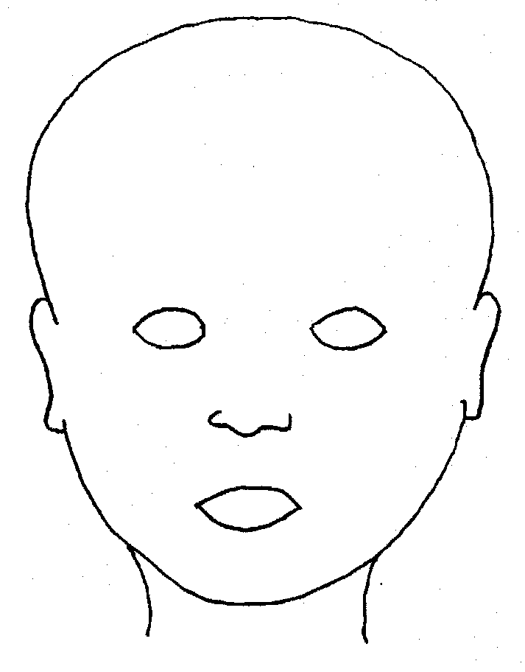 |  | 
FRONT |  | BACK
 |  | 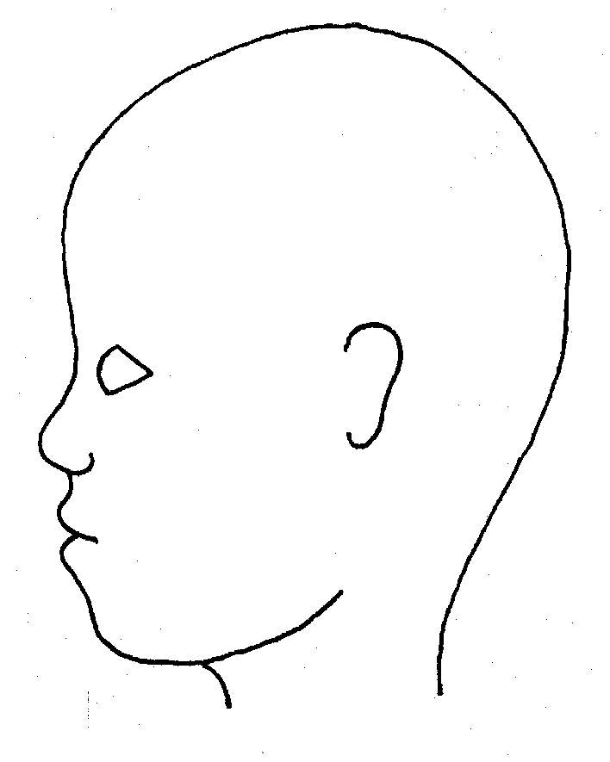
RIGHT |  | LEFT

Name of pupil: |  |  |  |  |  |  | Date and time of observation:
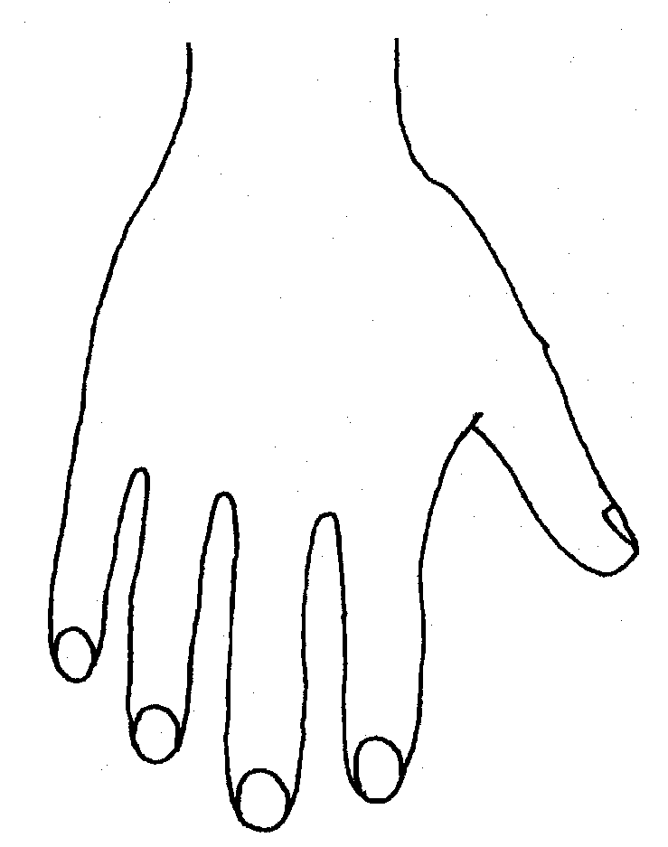 |  |  |  |  |  | 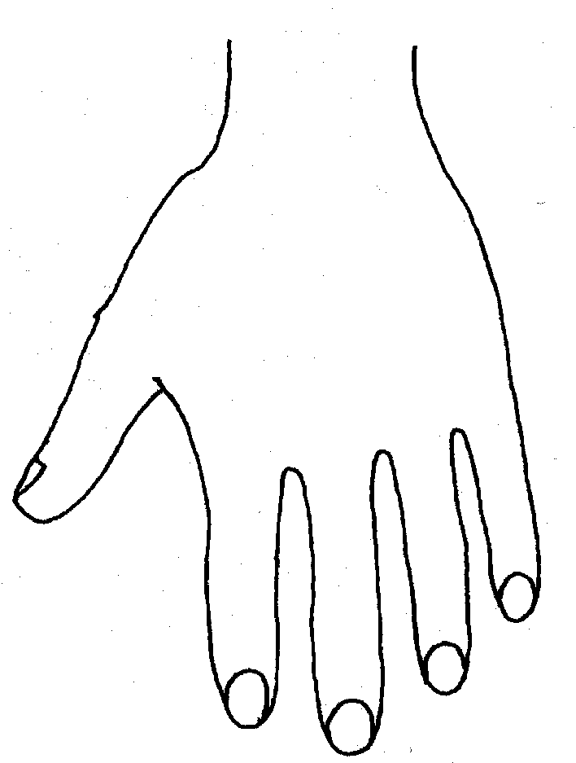
R |  |  |  |  |  | L
BACK
 |  |  |  |  |  | 
Name of Pupil: |  |  |  |  |  |  | Date and time of observation:
 |  |  |  |  | 
R | TOP |  |  | L | R |  |  | BOTTOM |  |  |  | L
 |  |  |  |  | 
R |  |  |  |  | L
INNER
 |  |  |  |  | 
R |  |  |  |  | L
OUTER
Printed Name, Signature and Job title of staff:

Appendix E
Preventing Radicalisation and Extremism

Rationale

Children are vulnerable to extremist ideology and radicalisation. In today’s modern world, children may be exposed to many radical and extremist views, both through the people they may meet and through a wide range of media. There is no single way of identifying whether a child is likely to be susceptible to an extremist ideology. Background factors combined with specific influences such as family and friends may contribute to a child’s vulnerability. As with other safeguarding risks, staff should be alert to changes in children’s behaviour which could indicate that they may be in need of help or protection. Staff should use their judgement in identifying children who may be at risk of radicalisation and act proportionately which may include the DSL (or deputy) making a referral to the Channel programme.

Similar to protecting children from other forms of harm and abuse, protecting children from this risk is part of All Saints Schools Trust’s safeguarding approach.

Extremism is the vocal or active opposition to our fundamental values, including the rule of law, individual liberty and the mutual respect and tolerance of different faiths and beliefs. This also includes calling for the death of members of the armed forces.
Radicalisation refers to the process by which a person comes to support terrorism and extremist ideologies associated with terrorist groups.
Terrorist is an action that endangers or causes serious violence to a person/people; causes serious damage to property; or seriously interferes or disrupts an electronic system. The use or threat must be designed to influence the government or to intimidate the public and is make for the purpose of advancing a political, religious or ideological cause. (Definitions are from current Government policy).

The PREVENT Duty and Channel

All schools and colleges are subject to a duty under section 26 of the Counter-Terrorism and Security Act 2015 (the CTSA 2015), in the exercise of their functions, to have “due regard to the need to prevent people from being drawn into terrorism”. This duty is known as the Prevent duty.

The Prevent duty is seen as part of our school’s wider safeguarding obligations. The Designated safeguarding lead and deputies should familiarise themselves with the Revised Prevent duty guidance: for England and Wales, especially paragraphs 57-76 which are specifically concerns with schools (and also covers childcare). The guidance is set out in terms of four general themes: Risk assessment, working in partnership, staff training, and IT policies.

Additional Support

Channel

Channel is a voluntary, confidential support programme which focuses on providing support at an early stage to people who are identified as being vulnerable to being drawn into terrorism. It provides a mechanism for schools to make referrals if they are concerned that an individual might be vulnerable to radicalisation. An individual’s engagement with the programme is entirely voluntary at all stages. Guidance on Channel is available at: Channel Guidance, and a Channel awareness e-learning programme is available for staff at: Channel General Awareness.

The school’s Designated Safeguarding Lead (and deputies) should be aware of local procedures for making a Channel referral. As a Channel partner, the school may be asked to attend a Channel panel to discuss the individual referred to determine whether they are vulnerable to being drawn into terrorism and consider the appropriate support required.

In School Approach

Children at All Saints Schools Trust are privy to a host of avenues where radicalisation and extremism is discussed:

Students are also taught about having their own voice and not always heeding the views of other people, especially if they have doubts about them.

The PSHE & RE curriculum covers aspects of bullying and rights.

The school has an internal referral process whereby staff can flag up any concerns they have around radicalisation and extremism. Any colleague with concerns should complete a Concern Form available in the staffroom and pass immediately to the Head of School/DSL. The DSL may then make a VTR (Vulnerable to Radicalisation) referral; at this stage parents should not be informed.

The concern is logged, and a timeline started. The Police and Social Services will be contacted. The school has a risk assessment in place and identifies students who may be at risk of Radicalisation and Extremism.

Radicalisation and Extremism Concern Form

Student name: | Staff logging concerns: | Date:
Nature of concern: |  | Tick:
Inappropriate content on phone

Inappropriate material held by student

Propaganda material

Overheard conversation

Gang mentality

Other concern

Describe in as much detail as possible your concern and note any behaviours observed:

Please continue over if necessary

Once completed hand this form IMMEDIATELY to a DSL

Radicalisation and Extremism Risk Assessment

The School
Question |  | Answer |  | Evidence/comment
Does the school have a policy |  | Yes |  | Part of Safeguarding policy
Does the school work with outside agencies on R and E |  | yes |  | Police and Social Care
Has the school got a nominated R and E Lead |  | yes |  | Melanie Barrow (CEO)
Do staff have a process to voice their  concerns |  | yes |  | Internal Referral Form
Do children have a process to voice their concerns |  | yes |  | Class teacher, Headteachers/ Head of School
Are there opportunities for students to learn about R and E |  | yes |  | PSHE lessons and  assemblies
Are there documented cases of R and E at the school |  | yes |  | Cohort of students are white British majority and Primary aged, no issues have ever been raised yet.
Is the school particularly prone to R and E |  | no
The schools conduct an annual Remembrance Service with the local British Legion Office held in school. All students participate in the service and pay their respects as an entire cohort. We also celebrate British Values.
Evaluation: | LOW RISK |  | Policy needs to be reviewed by Governing  Body every new academic year. Assemblies and curriculum are sufficient to provide students’ knowledge of R and E and what to look for to protect themselves and others at Primary School age.

The Students
Question |  | Answer | Evidence/comment
Are students aware of what R and E is |  | Yes- age appropriately | Assemblies, RE lessons and through PSHE
Are individual students risk assessed |  | yes | If a R &E concern form is filled in.  Students who are perceived to be vulnerable are identified early and flagged up to all staff.
Students at risk |  | none | Always monitoring situation
Evaluation: | LOW RISK |  | Staff will continue to monitor all students.

The community
The local community which the school serves consists predominantly of white British families.

Evaluation: | LOW RISK | As and when a concern is raised or an issue  appears likely the school will work with families and the wider community on R & E.

PREVENT SELF ASSESSMENT

PREVENT OBJECTIVE 1: Clear leadership and accountable structures are in place and visible throughout the organisation
Evidence: | Tick:
There is an identified strategic PREVENT lead within the Trust | - Melanie Barrow and DSLs
The strategic lead understands the expectations and key priorities to deliver PREVENT and that this is embedded within Safeguarding Procedures | ✓
The Senior Leadership Team are aware of the PREVENT Strategy and its objectives | ✓
There is a clear awareness of roles and responsibilities throughout organisation regarding PREVENT | ✓  Staff understand the need to flag up concerns and there is a clear process  to follow
PREVENT safeguarding responsibilities are explicit within the Schools Safeguarding Team | ✓  R and E is connected to Safeguarding  and Child Protection Policy and systems in school
The Prevent agenda and its objectives has been embedded within the appropriate Safeguarding processes | ✓

PREVENT OBJECTIVE 2: Staff and the Governing Body have been appropriately trained according to their role
Evidence: | Tick:
Further training on the Prevent agenda is made available to the Strategic Prevent lead and Safeguarding  leads where appropriate | All Staff and Govs complete  online  - Channel Training
There is appropriate staff guidance and literature available to staff on the Prevent agenda | - There is appropriate staff guidance and literature available to staff on the Prevent agenda

PREVENT OBJECTIVE 3: An appropriate reporting and referral process is in place and referrals are being managed effectively
Evidence: | Tick:
Ensure that preventing young people from being exposed to radicalisation or extremism is part of the school’s safeguarding  policies and procedures. | - Also in  safeguarding policy and  part of staff  induction
A single point of contact [SPoC] for any PREVENT concerns raised by staff within the school has been identified | - Melanie Barrow
An appropriate internal PREVENT referral process has been  developed | - Referral form  and clear process
Partner agency communication channels have been developed | - PREVENT  Lead at Suffolk Police  (Andy Hill, Sgt 3482)  first port of call when outside agencies  need to be consulted  or for making a Channel referral.
An audit trail for notification reports/referrals exists | - Time line of event created  once referral is made
PREVENT referrals/notifications are being managed or overseen by relevant staff
A process is in place to identify and develop ‘lessons learnt’ | - School would consult with  county safeguarding lead and Sgt  Andy Hill

PREVENT OBJECTIVE 4: A broad and balanced curriculum that helps protect students against extremism and promotes community cohesion
Evidence: | Tick:
School has a range of initiatives and activities that promote the spiritual, moral, social and emotional needs  of children aimed at protecting them from radicalisation and extremist influences | - PSHE,  assemblies and Ethics  curriculum
The school delivers training that helps develop critical thinking skills around the power of influence, particularly on-line and through social  media. | - PSHE  lessons, RE lessons,  assemblies  etc
Students are aware of the benefits of community cohesion and the  damaging effects of extremism on community relations. | - Through  PSHE, RE  and assemblies
Staff are able to provide appropriate challenge to students, parents or governors if opinions are expressed that are contrary to  fundamental British values and promotion of community cohesion. | - referral system in  place that  follows safeguarding processes

Preventing radicalisation
Children are vulnerable to extremist ideology and radicalisation. Similar to protecting children from other forms of harm and abuse, protecting children from this risk should be a part of a school’s or college’s safeguarding approach.

Extremism is the vocal or active opposition to our fundamental values, including the rule of law, individual liberty and the mutual respect and tolerance of different faiths and beliefs. This also includes calling for the death of members of the armed forces.

Radicalisation refers to the process by which a person comes to support terrorism and extremist ideologies associated with terrorist groups.

There is no single way of identifying whether a child is likely to be susceptible to an extremist ideology. Background factors combined with specific influences such as family and friends may contribute to a child’s vulnerability. Similarly, radicalisation can occur through many different methods (such as social media) and settings (such as the internet).

However, it is possible to protect vulnerable people from ideology and intervene to prevent those at risk of radicalisation being radicalised. As with other safeguarding risks, staff should be alert to changes in children’s behaviour which could indicate that they may be in need of help or protection. Staff should use their judgement in identifying children who may be at risk of radicalisation and act proportionately which may include the designated safeguarding lead (or deputy) making a referral to the Channel programme.

The Prevent duty
All schools and colleges are subject to a duty under section 26 of the Counter-Terrorism and Security Act 2015 (the CTSA 2015), in the exercise of their functions, to have “due regard to the need to prevent people from being drawn into terrorism”.This duty is known as the Prevent duty.

The Prevent duty should be seen as part of schools’ and colleges’ wider safeguarding obligations. Designated safeguarding leads and other senior leaders should familiarise themselves with the Revised Prevent duty guidance: for England and Wales, especially paragraphs 57-76 which are specifically concerns with schools (and also covers childcare). The guidance is set out in terms of four general themes: Risk assessment, working in partnership, staff training, and IT policies.

Additional support
The department has published advice for schools on the Prevent duty. The advice is intended to complement the Prevent guidance and signposts other sources of advice and support.

There is additional guidance: Prevent duty guidance: for further education institutions in England and Wales that applies to colleges.

Educate Against Hate, a website launched by Her Majesty’s Government has been developed to support and equip school and college leaders, teachers, and parents with information, tools and resources (including on the promotion of fundamental British values) to help recognise and address extremism and radicalisation in young people. The platform provides information on and access to training resources for teachers, staff and school and college leaders, some of which are free such as Prevent e-learning, via the Prevent Training catalogue.

Channel
Channel is a programme which focuses on providing support at an early stage to people who are identified as being vulnerable to being drawn into terrorism. It provides a mechanism for schools to make referrals if they are concerned that an individual might be vulnerable to radicalisation. An individual’s engagement with the programme is entirely voluntary at all stages. Guidance on Channel is available at: Channel Guidance, and a Channel awareness e-learning programme is available for staff at: Channel General Awareness.

The school or college’s Designated Safeguarding Lead (and any deputies) should be aware of local procedures for making a Channel referral. As a Channel partner, the school or college may be asked to attend a Channel panel to discuss the individual referred to determine whether they are vulnerable to being drawn into terrorism and consider the appropriate support required.

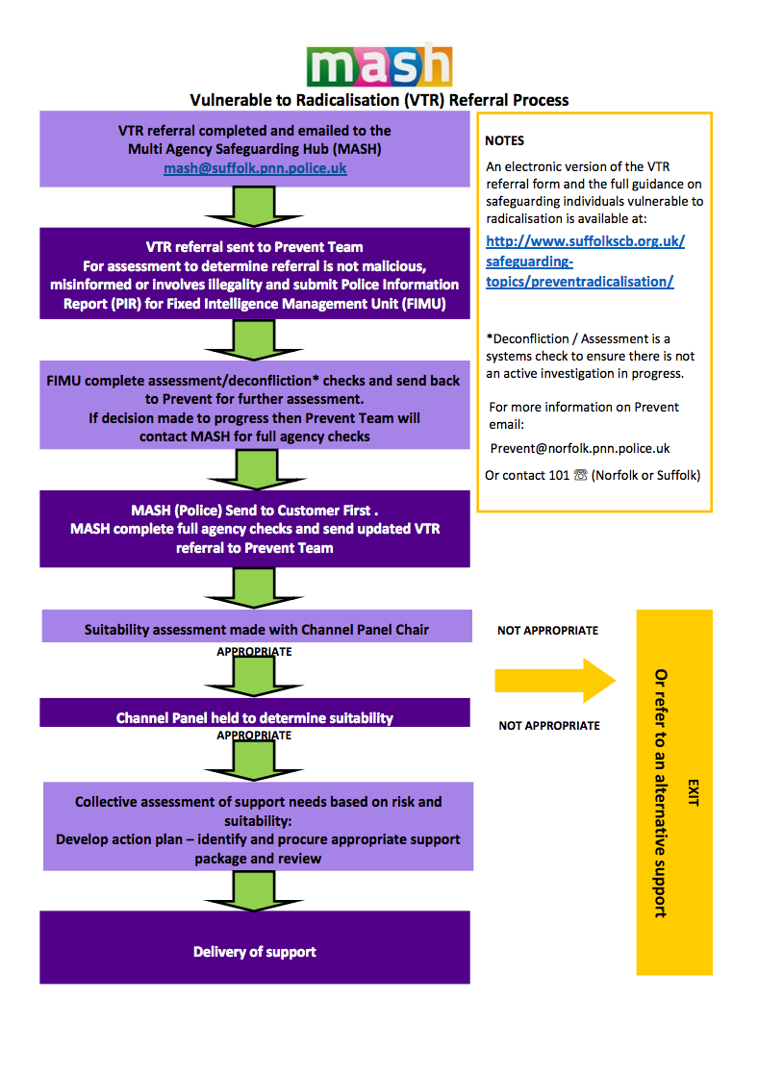

Annex A of KCSiE is a condensed version of Part One of KCSiE.
Section 175, Education Act 2002 – for management committees of pupil referral units, this is by virtue of regulation 3 and paragraph 19A of Schedule 1 to the Education (Pupil Referral Units) (Application of Enactments) (England) Regulations 2007
Anyone coming into contact with children in school is expected to only read the condensed version of Part One of KCSiE.
condensed version of KCSiE.
Under section 5B(11) (a) of the Female Genital Mutilation Act 2003, ‘teacher’ means, in relation to England, a person within section 141A(1) of the Education Act 2002 (persons employed or engaged to carry out teaching work at schools and other institutions in England)
UKCIS guidance: Sharing nudes and semi-nudes advice for education settings.
The government has made regulations which will make the subjects of Relationships Education (for all primary pupils) and Relationships and Sex Education (for all secondary pupils) and Health Education (for all pupils in state funded schools) mandatory from September 2020.
N.B. The exception to this process will be in those cases of known FGM where there is a mandatory requirement for the teacher to report directly to the police, although the DSL should also be made aware.
Under Section 5B(11)(a) of the Female Genital Mutilation Act 2003, “teacher” means, in relation to England, a person within section 141A(1) of the Education Act 2002 (persons employed or engaged to carry out teaching work at schools and other institutions in England).
Section 5B(6) of the Female Genital Mutilation Act 2003 states teachers need not report a case to the police if they have reason to believe that another teacher has already reported the case.
As defined in the Government’s Counter Extremism Strategy
As defined in the Revised Prevent Duty Guidance for England and Wales
As defined in the Terrorism Act 2000 (TACT 2000)
According to the Prevent duty guidance ‘having due regard’ means that the authorities should place an appropriate amount of weight on the need to prevent people being drawn into terrorism when they consider all the other factors relevant to how they carry out their usual functions.
“Terrorism” for these purposes has the same meaning as for the Terrorism Act 2000 (section 1(1) to (4) of that Act).
Legislation.gov.uk
It is important school and college staff (and especially designated safeguarding leads and their deputies) understand consent. This will be especially important if a child is reporting they have been raped, More information here
PSHE Teaching about consent from the PSHE association provides advice and lesson plans to teach consent at Key Stage 3 and 4.
It is important to differentiate between consensual sexual activity between children of a similar age and that which involves any power imbalance, coercion or exploitation. Due to their additional training, the designated safeguarding lead (or deputy) should be involved and generally speaking leading the school or college response. If in any doubt, they should seek expert advice.
Project deSHAME from Childnet provides useful research, advice and resources regarding online sexual harassment.
The Voyeurism (Offences) Act 2019 which amends the Sexual Offences Act 2003 to make upskirting a specific offence of voyeurism. The Act came into force on 12 April 2019
Additional information can be found at GOV.UK
As defined in the Government’s Counter Extremism Strategy
As defined in the Revised Prevent Duty Guidance for England and Wales
According to the Prevent duty guidance ‘having due regard’ means that the authorities should place an appropriate amount of weight on the need to prevent people being drawn into terrorism when they consider all the other factors relevant to how they carry out their usual functions.
⁴“Terrorism” for these purposes has the same meaning as for the Terrorism Act 2000 (section 1(1) to (4) of that Act).

