Aims of our provision in regards to pupils with SEND
- We make reasonable adjustments and tailor our provision for pupils who need this, which is “additional to and different from” that provided within the differentiated curriculum, in regards to the four broad areas of need:
  - Communication and interaction,
  - Cognition and learning,
  - Social, emotional and mental health,
  - Sensory/physical.
- We ensure that children and young people with SEN engage in the activities of the school, and can access the curriculum, alongside pupils who do not have SEN.
- We aim to build positive relationships with parents and carers, enabling them to express their views, concerns and wishes.
- We take pupils’ views into account to involve them in the decision-making process e.g. through creation of One Page Profiles. We focus on each child with SEN as an individual, highlighting their strengths and capabilities as well as areas they need extra support with, enabling both children and their parents to help identify what works best for them.
- We ensure a high level of staff expertise to meet pupil needs, through well-targeted continuing professional development.
- We support pupils with medical conditions to achieve full inclusion in all school activities by ensuring consultation with health and social care professionals.
- We work in cooperative and productive partnership with the Local Authority, the Specialist Education Services and other outside agencies, to ensure there is a multiprofessional approach to meeting the needs of all vulnerable learners.

What are special educational needs (SEN) or a disability?
The SEND Code of Practice (2014) defines:
- Special Educational Needs: A child or young person has special educational needs if they have a learning difficulty or disability which calls for special educational provision to be made for them.
  - A learning difficulty or disability is a significantly greater difficulty in learning than the majority of others of the same age.
  - Special educational provision means educational or training provision that is additional to, or different from, that made generally for others of the same age in a mainstream setting in England.
- Disability: Many children and young people who have SEN may have a disability under the Equality Act 2010 – that is ‘…a physical or mental impairment which has a long-term and substantial adverse effect on their ability to carry out normal day-to-day activities’. This definition includes sensory impairments such as those affecting sight or hearing, and long-term health conditions such as asthma, diabetes, epilepsy, and cancer.

How are children identified as having Special Educational Needs (SEN)?
At St. Peter & St. Paul Primary School, children are identified as having SEN through a variety of ways, including:
- Child performing below age-expected levels, which may be evident in baseline assessments, phonics assessments, end of Key Stage SATs etc.
- Concerns raised by a parent, carer, or a teacher, e.g. behaviour or self-esteem affecting performance. This may be supported by the SENCO observing the child.
- Liaison with external agencies (e.g. NHS Speech and Language)
- Health diagnosis through a paediatrician
- Liaison with previous school or schools within the MAT, including pre-school checks
- External assessment tools to support identification of difficulties (e.g. NELI Assessment in Year R, screeners administered by the SENCO e.g. Dyslexia in Year 3 and above, Speech Sounds, Phonological Awareness)

How will parents be informed about their child’s learning and targets?
- If a teacher has initial concerns about a child’s learning or behaviour, these concerns will be discussed with parents in the first instance.
- If a child is on the Special Educational Needs and/or Disabilities (SEND) register, parents will be informed by the class teacher.
- A One Page Profile will be co-created by the child and a member of staff (usually the SENCO), which outlines their strengths and needs.
- All children on the SEN register will have a Pupil Passport, which is a working document that identifies children's targets for the term and how the child, parents and the school can help achieve those targets. Their class teacher and the SENCO will then monitor and review your child’s progress as appropriate - these targets will be discussed and reviewed with parents at our termly Parents Evenings.
  - If a child has an EHCP, their Pupil Passport targets will be directly linked to their EHCP outcomes.

How is the decision made about what support my child will receive?
- With parental consent, and where appropriate, the SENCO can make referrals for an assessment of ADHD or ASD through the NHS NDD Pathway, speech and language support through the NHS, or a private Educational Psychologist assessment.
- If a child has an Education, Health and Care Plan (EHCP), this will specify the support needed for the child. We will also arrange Annual Review meetings with parents and any other professionals involved, to ensure that the plan is still appropriate for the child and make any necessary changes.
- For all other children with an identified additional need, either on our SEND register or not, the type of support given to the child will depend on their needs, and the adults available in class to support them (this may be 1:1 or in a small group). Their support and targets will be reviewed at least termly, with advice from the SENCO and in meetings with parents, which will be recorded in their Pupil Passport.

How will the school support my child?
The level of support a child will receive will depend on their needs. Where possible, we wish to meet the needs of children through ‘quality first teaching’ in the classroom and through our Universal Offer (see separate document on our school website). However, we recognise that in some cases, additional help is necessary. This can include:
- Differentiated learning within the classroom so that all children can access the curriculum at their level. This may include additional adult support, or adapted resources.  - Small group interventions (e.g. Precision Spelling, Colourful Semantics, Lego Therapy).  - Visual timetables for all children to help with routine and structure of the day, as well as now / next boards and sand timers for children who need more support with structuring the school day and understanding how long to focus for.  - Provision of differentiated resources and specific environmental adaptations within class such as ear defenders, pencil grips, writing slopes, colour overlays, use of adaptive technology e.g. typing, and personalised learning aids e.g. word mats and sound mats.  - An emphasis on emotional and mental health through our PSHE curriculum, as well as extra support for some children using the ‘Zones of Regulation’ approach and if necessary access to ELSA trained member of staff (Emotional Literacy Support Assistant). Referrals to our MAT play therapist or the School Nursing team can be arranged for children who may need further support.  - For some children, access to a quiet space is appropriate. Some children may use break cards or have scheduled movement breaks / sensory circuits within their timetable. For children who need a more bespoke sensory diet, our Nurture room has beanbags and egg chairs, a tent and a tunnel, toys and books and sensory lights. These spaces allow our children with communication/ interaction and sensory needs to take a calm break away from the classroom when needed. Some children may use  - Incorporation into planning of any advice or guidance provided by external professionals, including the SES and NHS Speech and Language Therapists / Occupational Therapists (following the four step approach of Assess, Plan, Do, Review).  - Coordinated planning or sharing ideas between class teacher, teaching assistants and SENCO.  - Providing specific training for staff to prepare for child entering the school with needs that have not been previously supported. | 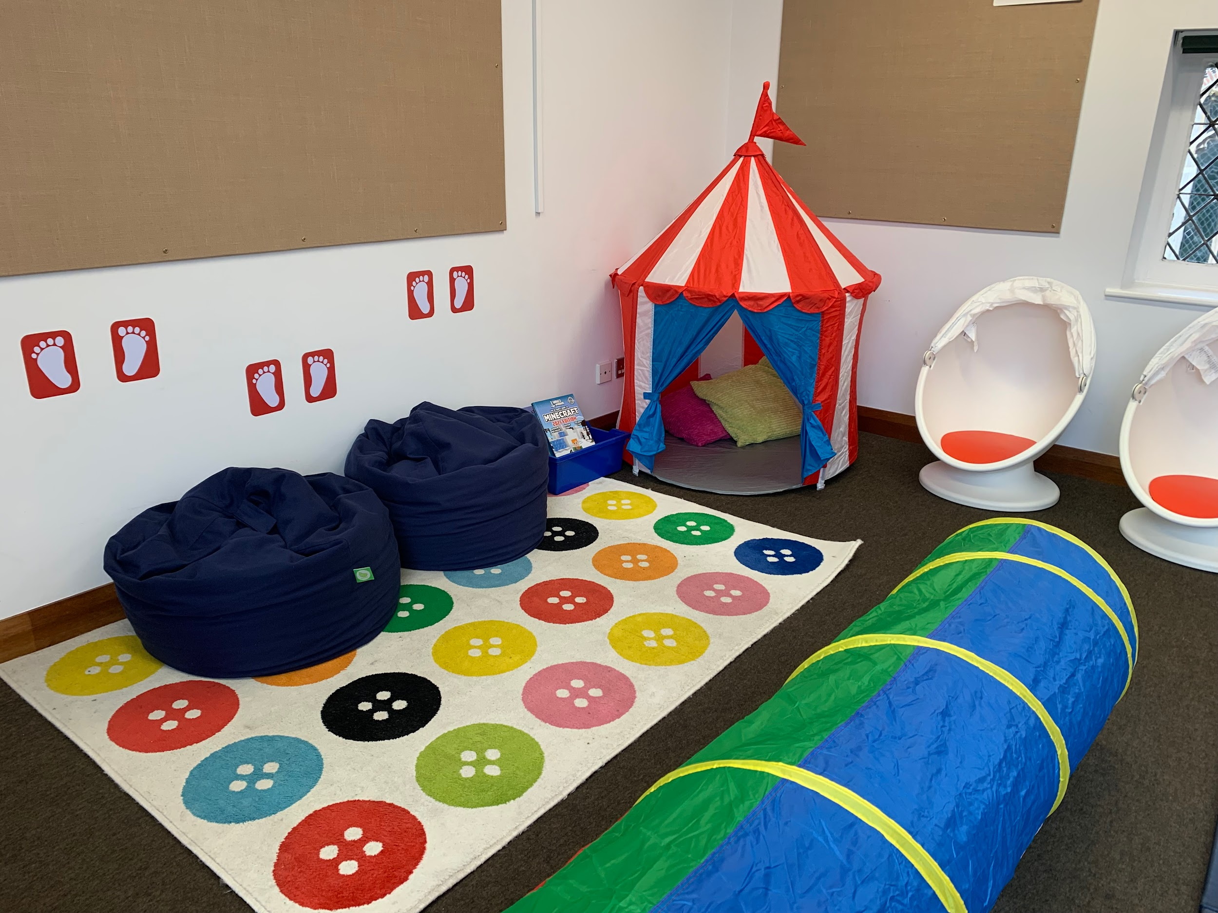  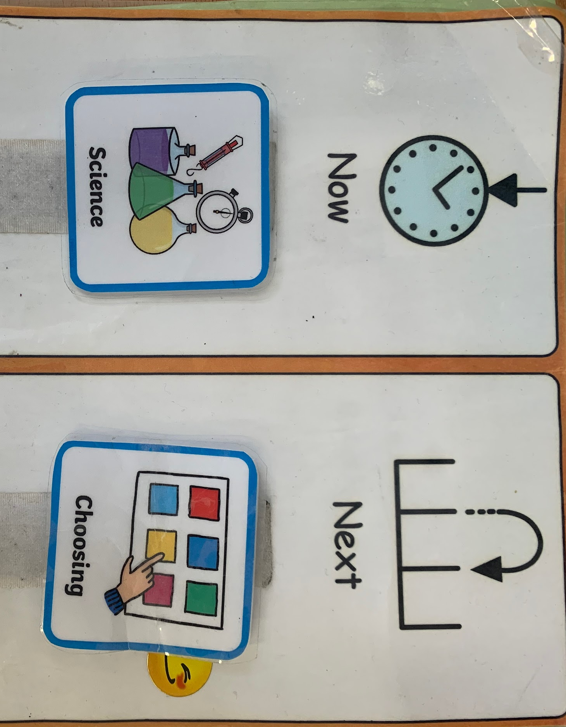  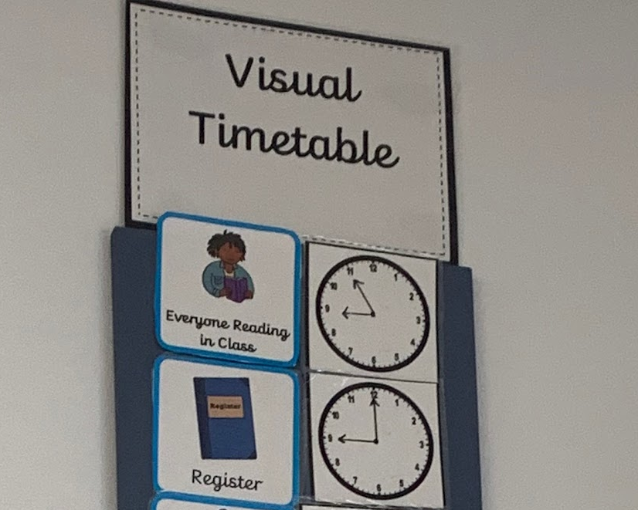  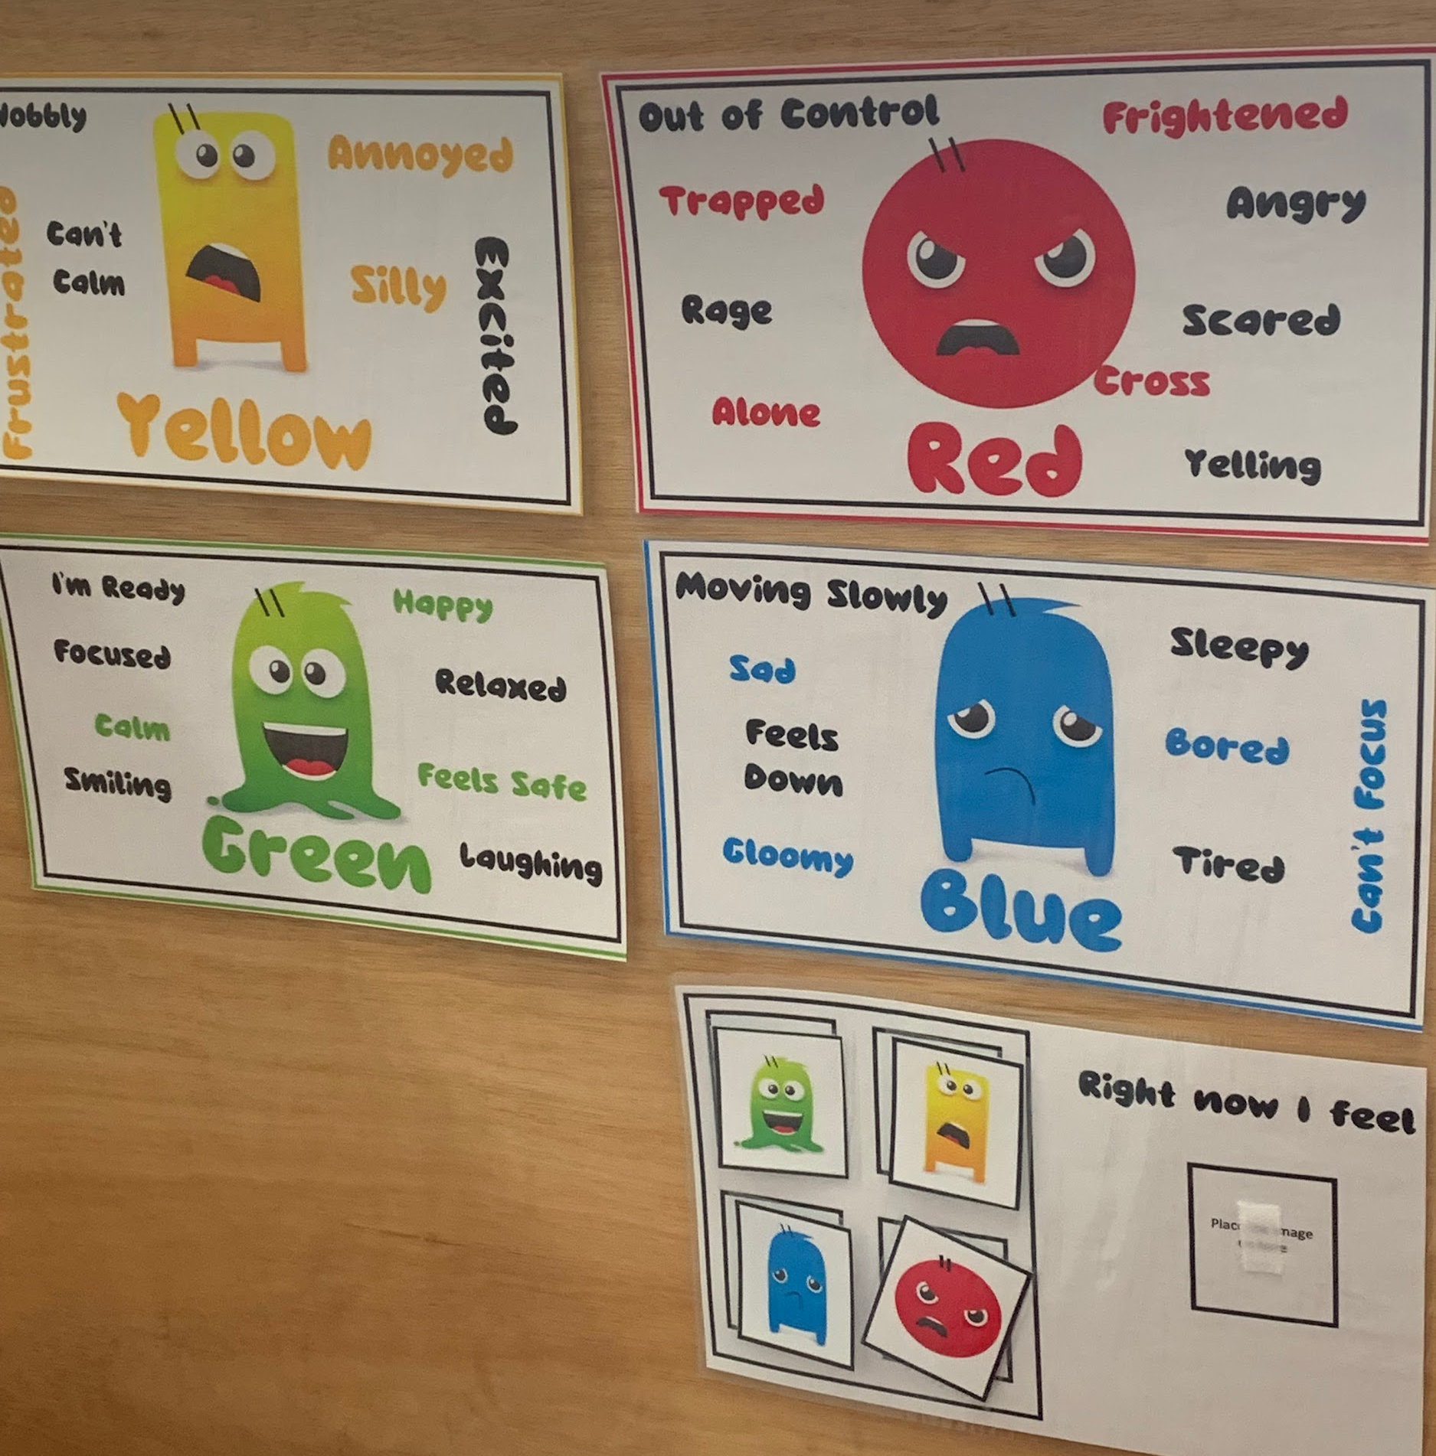

How will the school evaluate the effectiveness of the SEN provision made for pupils?
- Pupil Passports, as well as meeting with parents and external professionals, allow us to reflect on our current practice and provision, and review children’s targets and our own strategies regularly. Targets need to be small, measurable, achievable, realistic and time-sensitive: this is monitored and supported by the SENCO.
- The SENCO completes an annual Sensory Audit on the environment of each classroom and the common areas to see whether any further adjustments can be made to make school less overwhelming for some children with sensory needs.
- The effectiveness of SEN provision will also be measured using both qualitative and quantitative data. Qualitative data will involve the SENCO discussing the child with teachers, parents, and the child themselves on how successful the provision has been in enabling them to attain their outcomes (through SEN focused learning walks or meetings). Quantitative data (e.g. standardised tests) will examine both progress and attainment levels compared to those achieved nationally for pupils with the same prior learning level, to monitor the academic progress being made. This progress will be monitored and discussed by the Headteacher and class teacher at Pupil Progress Meetings.

What about medical needs?
- Where a child has medical needs, a Health Care plan is put together to ensure the child is safe and that the staff are aware of the child's specific needs. We would identify any specific training needed in order to ensure the child's medical needs were appropriately provided for in school. Everyone in school is aware of all specific health needs, and these are recorded on Arbor (our school management system) so that all members of staff can easily access this information.
- Disabilities and medical needs are taken into account when planning Forest School, as well as extra curricular activities such as clubs and trips. Whenever possible, we will ensure that all activities are accessible for all of our pupils, however if a risk assessment shows potential barriers or hazards for a child with a disability or medical need, this would be discussed with the parent or carer.

What training have staff received?
Over recent years, all staff have received training on:
- Neurodiversity
- Positive Handling
- Supporting children with Autism Spectrum Disorder and Dyslexia
- Using Colourful Semantics to support writing
Some staff have also sought out training to support:
- Trauma-Informed Schools
- Memory and Processing Difficulties
- Strategies for Dyscalculia
- Supporting children with ADHD
- Emotional / Mental Health First Aid

Further Information and Useful Links
If you have any questions about this report or about SEND at St. Peter and St. Paul Primary School, the appropriate people to contact are:
Sophie Brown (SENCO)
Gemma Watts (Headteacher)

- Link to Suffolk SEND Local Offer: Suffolk SEND Local Offer | Community Directory
- Suffolk SENDIASS (Support for Families): https://suffolksendiass.co.uk/
- Suffolk’s Emotional Wellbeing Gateway: https://infolink.suffolk.gov.uk/kb5/suffolk/infolink/infolink.page?infolinkchannel=2-1-1
- SEND Code of Practice: https://www.gov.uk/government/publications/send-code-of-practice-0-to-25
- Government Information on SEND: https://www.gov.uk/education/special-educational-needs-and-disability-send-and-high-needs

