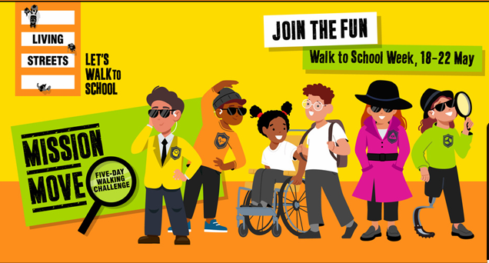
Dear Parent/Carer,
Our school is taking part in Walk to School Week (18-22 May). The nationwide event is organised by walking charity Living Streets and designed to help pupils experience first-hand the importance of walking to school. Children will be well on their way to reaching their recommended minimum 60 minutes of physical activity per day before even reaching the school gates! Not only will it set them up for a positive day in the classroom, but it will also help create healthy habits for life.
This year’s challenge, Mission Move, encourages children to travel actively to school every day of the week. Meeting our friendly cartoon secret agents along the way, pupils will learn about the important reasons to walk or wheel and its benefits for individuals, communities and the environment! Each pupil will be challenged to travel sustainably (walk, wheel, scoot, cycle or Park and Stride) to school every day for one week using the wallchart and stickers to log their journeys. Each class will work collectively to make as many active journeys to school as possible across the week. Individual activity diaries, daily stickers and end of week pupil rewards will complement this activity, reinforcing the benefits and keeping children engaged.
What do I need to do as a parent/carer? We would ask, if possible, to make arrangements so that your child/children can travel actively to school on week commencing 18 May, helping our school reduce congestion and pollution around the school gates. Your child will earn special stickers and a reward trophy! Walking, wheeling, scooting and cycling all count! If you live far away from school and need to drive or take public transport, try parking the car in the free car parks in Eye and walking the rest of the journey.
Thank you in advance for your cooperation,
Miss Rachel Norton.

