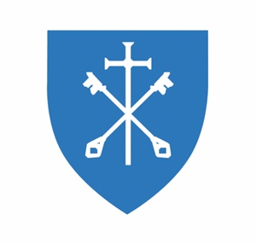
St Peter & St Paul CE Primary School, Eye
Church Street, Eye, Suffolk, IP23 7BD
Tel: 01379 831500
Email: office@eyeprimary.org.uk
Executive Head Teacher: Mrs G Watts
Head of School: Mrs C Jarvis
https://www.stpeterandstpaulschool.co.uk/

3 July 2026

Dear Parent/Carer,

I am writing to let you know about a delay to this year's Key Stage 2 (KS2) test results, which affects all schools nationally.
Schools were due to receive results on 7 July 2026. However, Pearson Education Limited, the provider responsible for administering, marking, and returning Key Stage 2 results to schools has informed the Department for Education of a delay affecting the national system used to make results available to schools. Results will now be available on 16 July 2026.

Importantly, the delay is not related to the quality of the tests or the accuracy of pupils' results. Test papers have been marked in line with usual processes.

This will not impact your child’s transition to secondary school and no action is required from parents or pupils. We will share results with you as quickly as possible after we receive them on 16 July.

Thank you for your patience and understanding.

If you have any questions, please contact the school office.

Yours sincerely,

Gemma Watts
Executive Head Teacher

